Report of the Project Done in Complete Fulfilment of the Requirements for the Award of Degree of Bachelor of Technology in Electronics and Communication Engineering
DESIGN AND DEVELOPMENT OF QUADRUPED ROBOT
PROJECT PHASE II REPORT
Done by
JOSU DENNY Reg No: AJC22EC073
NOEL JOYCE VARGHESE Reg No: AJC22EC088
ROHAN P THOMAS Reg No: AJC22EC102
SHARON THOMAS Reg No: AJC22EC106

Under the guidance of
Dr. Abubeker K M
Associate Professor, Dept of ECE

Bachelor of Technology
in
Electronics & Communication Engineering
Department of Electronics & Communication Engineering
Amal Jyothi College of Engineering (Autonomous)
Kanjirappally – 686518
(Affiliated to APJ Abdul Kalam Technological University, Thiruvananthapuram)
APRIL – 2026
DEPARTMENT OF ELECTRONICS & COMMUNICATION ENGINEERING
AMAL JYOTHI COLLEGE OF ENGINEERING (AUTONOMOUS)
Kanjirappally – 686518
(Affiliated to APJ Abdul Kalam Technological University)

BONAFIDE CERTIFICATE
This is to certify that the project phase II report entitled “Design and Development of Quadruped Robot” is a Bonafide report of the Eighth Semester Project Phase II [ECD416] done by JOSU DENNY Reg No: AJC22EC073, NOEL JOYCE VARGHESE Reg No: AJC22EC088, ROHAN P THOMAS Reg No: AJC22EC102, SHARON THOMAS Reg No: AJC22EC106 in complete fulfilment of requirements for the award of degree of Bachelor of Technology in Electronics and Communication Engineering from APJ Abdul Kalam Technological University, on April 2026. They have done the phase II of the project with prior approval from the department.

Dr. Abubeker K M Mr. Agi Joseph George
Project Guide Project Coordinator
Associate Professor Assistant Professor

Dr. Therese Yamuna Mahesh
Head of the Department

ACKNOWLEDGEMENT

First, we sincerely thank the Almighty who is most beneficent and merciful for giving us the knowledge and courage to complete the preliminary work of the project successfully.
We derive immense pleasure in expressing our sincere thanks to the Principal Dr. Lillykutty Jacob, for her permission and for providing infrastructural facilities for the successful completion of our preliminary work of the project.
We express our gratitude to Dr. Therese Yamuna Mahesh, Head of the Department, ECE, for her encouragement and motivation during our preliminary work of the project. We express our heartfelt gratefulness to Dr. Abubeker K M, Associate Professor, Department of ECE, project guide, for his valuable guidance and suggestions during the project.
We also extend our sincere thanks to Er. Agi Joseph George, Assistant Professor and Dr. Gee Varghese Titus, Professor, Department of ECE for their kind support and coordination.
Finally, we appreciate the patience and solid support of our parents and enthusiastic friends for their encouragement and moral support for this effort.

JOSU DENNY
NOEL JOYCE VARGHESE
ROHAN P THOMAS
SHARON THOMAS

ABSTRACT

- This project presents the design and development of VANGUARD, a 12-Degree-of-Freedom (DOF) quadrupedal robotic platform engineered for semi-autonomous navigation and environmental mapping. The primary objective was to deploy complex locomotion and perception stacks onto a resource-constrained Raspberry Pi edge-computing hardware.

- The system architecture is partitioned into four modular layers: a Perception Layer utilizing YOLOv8 for real-time human detection and tracking, a Behaviour Layer for high-level decision making, an optimized C++ Locomotion Layer executing Inverse Kinematics (IK) for stable gait generation, and a Mapping Layer powered by ROS 2. To overcome the absence of wheel odometry, the robot utilizes a YDLIDAR T-mini plus with advanced scan-matching algorithms to generate 2D occupancy grids.

- Experimental results demonstrate successful integration of the decoupled software stack, achieving stable human-following behaviours and coherent spatial mapping in unstructured environments. This research provides a robust foundation for further development in odometry-free navigation and transitionary aerial-terrestrial robotics.

TABLE OF CONTENTS

i. ACKNOWLEDGEMENT i
ii. ABSTRACT ii
1. INTRODUCTION 1
1.1. Overview of Quadrupedal Robotics 1
1.2. The Vanguard Platform 1
1.3. Edge Computing in Robotics 1
1.4. Hierarchical Control Paradigm 2
2. MOTIVATION AND PROBLEM STATEMENT 3
2.1. Motive of the Project 3
2.2. Problem Statement 3
2.3. Project Objectives 3
3. LITRATURE SURVEY 4
4. SYSTEM ARCHITECTURE AND DESIGN 13
4.1. System Modelling 13
4.1.1. Perception Layer 13
4.1.2. Behaviour Layer 14
4.1.3. Locomotion Layer 14
4.1.4. Mapping Layer 15
4.2. Mechanical Design and 12-DOF Structural Analysis 15
4.3. Electronics Architecture and Signal Integrity 16
4.4. System Components and Servo Port Allocation 16
4.4.1. Circuit architecture and Interfacing 17
4.4.2. Servo Pin Allocation and Channel Mapping 18
4.4.3. Specialized sensor Integration 19
4.4.4. Control System and Software 20
5. DEVELOPMENT EVOLUTION & SYSTEM TESTING 18
5.1. Phase 1:Prototype Development (8-DOF ESP32/Arduino) 21
5.1.1. Analysis of Prototype Limitations 22
5.2. Phase 2:The VANGUARD Upgrade (12-DOF Rpi 5) 22
5.2.1. Centralized Processing : Raspberry Pi 5 22
5.2.2. The “Nervous System” I2C and PCA9685 23
5.2.3. 12-DOF Mobility and Inverse Kinematics (IK) 23
5.2.4. Perception and High-Speed Bus 24

6. FUTURE DEVELOPMENT 25
6.1. The VTOL Carrier Platform 25
6.2. The Winch Deployment Mechanism 26
6.2.1. Mechanism Design 26
6.2.2. Dedicated Winch Control PCB 26
6.3. Deployment Workflow 27
7. CONCLUSION 29
REFERENCES 30
APPENDIX 33

LIST OF FIGURES AND TABLES

Figure 4.1 Multilayer Architecture………..…………………………………………..13
Figure 4.2 Circuit Diagram of the Quadruped System………………………………..18
Figure 4.3 Circuit Diagram of the Quadruped System………………………………..19
Figure 5.1 8-DOF Built Robot……………………………………….………………..21
Figure 5.1 12-DOF Built Robot…..………………………………….………………..23
Figure 6.1 3D Printed Fuselage& Wings of VTOL.………………….………………..25
Figure 6.2 Connections Between winch & Flight Controller Board….………………..26
Figure 6.3 Custom Made Winch PCB Board.…….………………….………………..27
Figure 6.4 Depiction of how VTOL & Quadruped would work together….…………..28

Table 4.1: Component Functioning ………………………………………….…...17
Table 4.2: Servo to driver connections………………..…………………………..19

CHAPTER 1

INTRODUCTION

1.1 Overview of Quadrupedal Robotics
The evolution of mobile robotics has seen a significant shift from stationary industrial arms to autonomous mobile platforms capable of navigating human environments. Among these, quadrupedal (four-legged) robots represent a pinnacle of bio-inspired engineering, mimicking the skeletal and muscular coordination of mammals to achieve versatile mobility. Unlike wheeled robots, which are limited by the continuity of the surface they traverse, quadrupedal systems utilize discrete footholds, allowing them to step over obstacles, climb stairs, and maintain stability on highly irregular or inclined terrain.

1.2 The VANGUARD Platform
The VANGUARD robot is a specialized 12-Degree-of-Freedom (DOF) legged platform designed to explore the intersection of high-fidelity mechanical control and edge-based artificial intelligence. The system is built upon a modular architecture that separates physical execution from high-level cognitive tasks. By utilizing a 3-DOF configuration per leg, the VANGUARD platform can perform omnidirectional movement, including forward/backward walking, lateral shifting, and rotation in place, while maintaining a dynamic body posture.

1.3 Edge Computing in Robotics
A defining characteristic of this project is the reliance on a Raspberry Pi as the primary computational core. In modern robotics, high-level processing like Simultaneous Localization and Mapping (SLAM) and computer vision inference are often offloaded to powerful remote servers or bulky onboard PCs. VANGUARD challenges this paradigm by implementing a native, optimized control stack that handles:
- Real-time Locomotion: Executing complex Inverse Kinematics (IK) in C++ to ensure low-latency motor response.
- Computer Vision: Running YOLOv8-based neural networks for target identification at the edge.
- Spatial Mapping: Processing LiDAR data through ROS 2 to generate real-time occupancy grids without external assistance.

1.4 Hierarchical Control Paradigm
To manage the concurrent computational demands of high-level AI and low-level motor control, the project utilizes a hierarchical software abstraction. This involves a decoupled architecture where a Python-based Perception Layer handles environmental intelligence, and a high-performance C++ Locomotion Layer manages physical stability. This separation ensures that heavy visual processing tasks do not interrupt the high-frequency control loops required for stable walking gaits. By utilizing standard I/O piping between these layers, the system achieves a responsive, semi-autonomous behavior loop capable of human tracking and obstacle awareness.

CHAPTER 2

MOTIVATION AND PROBLEM STATEMENT

Motive of the Project

The primary motivation behind the VANGUARD project is to bridge the analytical gap between high-end research robotics and accessible, open-source hardware. While industrial platforms like the Boston Dynamics Spot have revolutionized the field, their proprietary nature and high cost limit their utility in general research and academic environments.
By developing a 12-DOF (Degree-of-Freedom) quadruped using a Raspberry Pi, this project seeks to prove that advanced locomotion control, such as Inverse Kinematics (IK), and sophisticated AI tasks, like YOLOv8 object detection, can be harmonized on a single edge-computing node. The motive is rooted in creating a modular system that can navigate complex spaces where traditional wheels fail and where GPS signals are unavailable, providing a baseline for future terrestrial and aerial autonomous systems.

Problem Statement

The development of a functional autonomous quadrupedal robot presents a set of concurrent engineering challenges that are significantly more complex than those of wheeled counterparts. A central issue lies in the coordination of high-DOF systems, where maintaining a stable center of gravity while executing walking gaits requires the simultaneous and precise timing of 12 independent servos. This physical complexity is compounded by severe computational constraints, as standard single-board computers often struggle to process high-resolution LiDAR data and real-time computer vision while maintaining the high-frequency control loops needed for movement.

Furthermore, the system must address the "Odometry Gap"; most SLAM algorithms rely on wheel encoders to estimate position, but in legged robotics, the lack of continuous contact and the presence of "foot slip" make traditional wheel odometry impossible. These software hurdles are accompanied by hardware risks, specifically the high current draw of multiple servos which can cause voltage drops and logic noise on the controller, potentially leading to system instability or hardware failure. Therefore, the core problem is creating an optimized, decoupled architecture that can handle physical stability and environmental intelligence simultaneously on limited hardware.

  - Project Objectives
The primary objective of this research is to design and implement a custom 12-DOF Inverse Kinematics (IK) engine in C++ that can solve for joint angles in real-time to ensure fluid and stable locomotion. Parallel to the motion control, the project aims to deploy a robust electronics interface using a PCA9685 PWM driver with a dedicated power supply unit to ensure isolated power delivery and protect the logic-level components of the Raspberry Pi. To achieve environmental awareness, the project intends to integrate a YOLOv8 vision pipeline that utilizes neural networks for human target identification and localization based on bounding box geometry.
Additionally, the project seeks to overcome the challenges of legged odometry by configuring ROS 2 to perform 2D mapping using a YDLIDAR T-mini plus through pure scan-matching. Finally, a major objective is the establishment of a decoupled control stack that allows a Python-based perception layer to communicate efficiently with a high-performance C++ locomotion layer through standard I/O piping. This holistic approach ensures that the VANGUARD platform can operate as a semi-autonomous unit capable of spatial mapping and target tracking in unstructured environments.

CHAPTER 3

LITRATURE SURVEY

[1]. P. Čížek, M. Zoula, J. Faigl, "Design, Construction, and Rough-Terrain Locomotion Control of Novel Hexapod Walking Robot With Four Degrees of Freedom Per Leg," IEEE Access, vol. 9, 2021. This paper presents the HAntR, a highly advanced hexapod robot featuring four degrees of freedom (DoF) per leg. Its compact, symmetrical body and roll-yaw-pitch-pitch leg configuration significantly enhance kinematic capabilities, weight distribution, and stability on sloped surfaces. The developed locomotion controller enables continuous body motion and seamless slope adaptation, allowing the robot to walk on inclines up to 31°. Experimental results demonstrate HAntR's exceptional endurance, capable of over an hour of operation while carrying a payload of 85% of its body weight, making it a superior platform for demanding SAR missions.
[2]. T. Karakurt, A. Durdu, N. Yilmaz, "Design of Six-Legged Spider Robot and Evolving Walking Algorithms," International Journal of Machine Learning and Computing, vol .5, no. 2, 2015. This study details the design and testing of the TKSPIDER1, a six-legged robot built for search and rescue operations. The robot employs three servo motors per leg and implements four distinct walking algorithms: wave, tripod, biped, and explorer gaits. The paper provides a comparative analysis of these gaits based on velocity and stability, with the tripod gait being the fastest and the explorer gait the most stable for rough terrain. The work underscores the critical importance of gait selection in adapting to varying environmental conditions during rescue missions.
[3]. M. P. Manuel, M. Faied, M. Krishnan, "A LoRa-Based Disaster Management System for Search and Rescue Mission", IEEE Internet of Things Journal, Vol. 11, No. 20, 2024. This research introduces the Titan DMS, a comprehensive system designed for worst-case disaster scenarios where traditional communication infrastructure has failed. The system integrates robot platooning for coordination, a Fuzzy Inference System Vector Field Histogram (FISVFH) for navigation, and a robust communication backbone using LoRa technology. It features custom devices like "EMERG" for victims to send SOS signals, "RoboMaC" for robot monitoring, and "RoboTalkie" for audio communication. Extensive outdoor experiments validate the system's capability to establish a base station and perform victim rescue operations reliably.
[4]. J. Li, G. Yang, Q. Cai, "Autonomous Aerial-Ground Cooperative Navigation Based on Information-Seeking in GNSS-Denied Environments", IEEE Internet of Things Journal, 2023. This paper addresses the critical challenge of navigation when GPS signals are unavailable. It proposes a cooperative framework where Unmanned Ground Vehicles (UGVs), equipped with higher-precision inertial sensors, actively optimize their formation to maximize positioning information for a supporting Unmanned Aerial Vehicle (UAV). Using Fisher Information Matrix (FIM) analysis and a Belief Propagation (BP)-based algorithm, the system significantly reduces accumulated navigation errors. This information-seeking strategy ensures high localization accuracy for the entire aerial-ground team in complex environments like tunnels.
[5]. L. Abraham, J. Jose, S. Biju, R. Kalantri, F. Biju, S. Rajguru, "Swarm Robotics in Disaster Management", International Conference on Emerging Technologies, 2019. This work explores the application of swarm robotics principles to disaster management. It highlights the advantages of using a coordinated group of drones for tasks such as surveying disaster zones, detecting survivors, and delivering emergency supplies. The paper discusses key implementation challenges, including network establishment, time synchronization among drones, and obstacle avoidance. It argues that swarm-based systems offer superior robustness, scalability, and fault tolerance compared to single-robot solutions in dynamic and large-scale disaster scenarios.
[6]. M. Hutter, C. Gehring, D. Jud, et al., "ANYmal - A Highly Mobile and Dynamic Quadrupedal Robot", IEEE/RSJ International Conference on Intelligent Robots and Systems (IROS), 2016. Building on the theme of legged mobility from [1] and [2], this seminal work presents ANYmal, a quadruped robot designed for dynamic and autonomous operation in complex environments. Utilizing series elastic actuators, ANYmal demonstrates remarkable abilities in traversing rough terrain, recovering from slips and falls, and even climbing stairs. Its high mobility serves as a benchmark for the kind of agile platform required for the quadruped robot envisioned in your project.

[7]. C. D. Bellicoso, F. Jenelten, C. Gehring, M. Hutter, "Dynamic Locomotion and Whole-Body Control for Quadrupedal Robots", IEEE International Conference on Robotics and Automation (ICRA), 2017. This research delves into the sophisticated control architecture necessary for dynamic legged locomotion, directly addressing the control complexity challenge highlighted in your project. The authors present a whole body controller that integrates motion planning with real-time force control, enabling a quadruped robot to perform dynamic maneuvers while maintaining balance. This approach is a critical step beyond the sequence control in [2] and is essential for achieving the agile and stable gait transitions your project requires.
[8]. M. Bjelonic, N. Kottege, P. Beckerle, "Proprioceptive Control of an Over Actuated Hexapod Robot in Unstructured Terrain", IEEE/RSJ International Conference on Intelligent Robots and Systems (IROS), 2016. Complementing the mechanical design in [1], this paper focuses on the control of a hexapod robot with 5-DoF legs (Weaver). It emphasizes proprioceptive control—using joint position and torque feedback—for blind locomotion over rough terrain. This sensor-less terrain adaptation is highly relevant for disaster sites where external sensors may fail, and it aligns with the need for robust, feedback-driven control as planned with your Petri Net model.
[9]. S. Khattak, C. Papachristos, K. Alexis, "Keyframe-based Thermal-Inertial Odometry for Autonomous Navigation of MAVs in GNSS-Denied Environments", IEEE International Conference on Robotics and Automation (ICRA), 2019. This work provides a solution to the GNSS-denied navigation problem, a theme central to [4]. It presents a visual-inertial odometry system for Micro Aerial Vehicles (MAVs) that is robust to challenging conditions, including darkness and smoke, by incorporating thermal imagery. Such perception-driven odometry is a crucial enabling technology for any robot, legged or aerial, that must operate autonomously in the degraded visual conditions typical of disaster sites.
[10]. F. Meyer, H. Wymeersch, M. Fröhle, F. Hlawatsch, "Distributed Estimation with Information-Seeking Control in Agent Networks", IEEE Journal on Selected Areas in Communications, Vol. 33, No. 11, 2015. Extending the information-seeking concept from [4] to a broader multi-robot context, this paper formalizes the integration of estimation and control. It presents a framework where robots not only share local estimates but also actively control their motion to maximize the information gained about their states and the environment. This theoretical foundation is directly applicable to enabling the cooperative swarm navigation required for your multi-robot SAR system.
[11]. R. O. Guerrero, G. T. M. D’Angelo, D. S. L. L. L. L. L., "Petri Net-Based Modeling and Control of Humanoid Robot Walking Gait", IEEE Transactions on Systems, Man, and Cybernetics: Systems, Vol. 50, No. 7, 2020. This paper directly validates the core control methodology of your project. It demonstrates the successful application of Petri Nets for modeling and controlling the complex, concurrent processes of a humanoid robot's walking gait. The results confirm that Petri Nets are highly effective for managing synchronization and concurrency in multi-legged systems, providing a strong theoretical and practical precedent for your proposed control system.
[12]. A. Breitenmoser, F. T. S. T. S., R. Siegwart, "Robust Communication for Multi Robot Systems in Unstructured Environments", IEEE Robotics and Automation Letters, Vol. 3, No. 4, 2018. Supporting the communication solution in [3] and your project's requirements, this research focuses on maintaining reliable communication links for robot teams in environments without infrastructure. It investigates the use of multi-radio systems and adaptive protocols to create a robust mesh network, ensuring that data and commands can be relayed even in the presence of obstacles and interference, which is vital for swarm operations in collapsed structures.
[13]. P. Deeg, C. A. Boano, M. A. M. A., K. Römer, "A LoRa-Based Meshed IoT Network for Live Monitoring of Glacier Dynamics", ACM Transactions on Sensor Networks, Vol. 18, No. 3, 2022. This study provides a real-world case study of LoRa technology deployed in a harsh, remote environment analogous to a disaster zone. It demonstrates the practical implementation of a long-range, low-power, meshed communication network for reliable data collection, further validating the choice of LoRa in [3] as a suitable technology for the telemetry needs of your SAR robot swarm.
[14]. J. Delmerico, E. Mueggler, J. N. N. J., D. Scaramuzza, "Active Autonomous Aerial Exploration for Ground Robot Path Planning", IEEE Robotics and Automation Letters, Vol. 2, No. 2, 2017. This paper explores the synergistic relationship between aerial and ground robots, a theme introduced in [4]. It presents a system where a UAV actively explores an unknown environment to build a map and efficiently plan paths for a UGV. This concept of aerial scouts aiding ground units is highly relevant for optimizing the search efficiency of a heterogeneous robot swarm in a large-scale disaster area.
[15]. K. Walas, D. Kanoulas, M. G. M. G., "Vision-Based Human Detection for Robotic Search and Rescue", Journal of Field Robotics, Vol. 36, No. 5, 2019. This research focuses on the end-goal of SAR: finding survivors. It develops and compares advanced computer vision and machine learning algorithms for robust human body detection using robot-mounted cameras in cluttered environments. The findings are directly applicable to the implementation of the ML-based survivor detection module that is a key component of your proposed robot's autonomy stack.
[16]. U. Saranli, M. Buehler, D. E. Koditschek, "RHex: A Simple and Highly Mobile Hexapod Robot", 2001. This foundational research explores the RHex platform, which utilizes a compliant leg design to navigate highly irregular terrain. For the VANGUARD project, this study provides the theoretical basis for "dynamic stability" in legged robots. It reinforces the idea that even with simplified mechanical structures, high mobility can be achieved through optimized power-to-weight ratios—a concept we applied using lightweight 3D-printed materials.
[17]. K. Berns, et al., "Experiments with a Stereo Camera Head for the Local Navigation of LAURON III", 1993. This paper investigates the use of active vision systems for the local navigation of legged robots. This is directly relevant to VANGUARD’s Phase 2 transition, as it validates the necessity of integrating a dedicated "Perception Head" (the USB camera and LiDAR) to provide the spatial data needed for autonomous decision-making in complex environments.
[18]. B. L. Luk, et al., "Intelligent Legged Climbing Service Robot for Remote Maintenance Applications", 2005. The authors discuss robots designed for hazardous environments, emphasizing the importance of remote monitoring and robust control. This supports VANGUARD’s requirement for a high-bandwidth Raspberry Pi 5 link, ensuring that the operator can receive reliable telemetry and video feedback when the robot is deployed in zones inaccessible to humans.
[19]. R. D. Quinn, K. S. Espenschied, "Control of a Hexapod Robot Using a Biologically Inspired Neural Network", 1993. This work proposes a control architecture inspired by biological neural networks to manage leg coordination. This research aligns with our objective of moving away from rigid, pre-programmed gait sequences toward more reactive, fluid patterns where the robot can adjust its gait dynamically based on real-time sensor feedback.
[20]. D. Belter, P. Skrzypczyński, "Integrated Motion Planning for a Hexapod Robot Walking on Rough Terrain", 2011. This study focuses on integrated motion planning to maintain balance on uneven ground. It provides the mathematical inspiration for VANGUARD’s 12-DOF Inverse Kinematics (IK), specifically regarding how to calculate a body trajectory that maintains the center of mass while negotiating obstacles.
[21]. J. Faigl, P. Čížek, "Adaptive Locomotion Control of Hexapod Walking Robot Walking Robot for Traversing Rough Terrains with Position Feedback Only", 2019. The authors prove that stable locomotion can be achieved using position feedback alone. This is highly relevant to our current hardware setup, as it validates our control strategy of using the PCA9685 driver to manage 12 servos without needing expensive, complex torque sensors for every joint.
[22]. A. Roennau, et al., "LAURON V: A Versatile Six-Legged Walking Robot with Advanced Maneuverability", 2014. This paper presents the LAURON V, a benchmark for robot maneuverability. It validates our choice of a 3-DOF leg configuration (Coxa, Femur, Tibia), as it details how this specific joint architecture allows for the omnidirectional movement and center-axis rotation implemented in our 12-DOF design.
[23]. J. Terven and D. Cordova-Esparza, "A Comprehensive Review of YOLO: From YOLOv1 to YOLOv8 and Beyond", 2023. As a critical reference for our perception layer, this paper provides a performance review of the YOLOv8 architecture. It justifies the use of YOLOv8 as the primary "eyes" of VANGUARD, highlighting the model's superior speed-to-accuracy ratio which allows the Raspberry Pi 5 to perform real-time survivor detection.
[24]. S. Cass, "The Raspberry Pi 5: The Benchmark for Single-Board Computers", 2023. This technical analysis justifies the transition from the ESP32 (Phase 1) to the Raspberry Pi 5 (Phase 2). The research details the BCM2712's ability to handle high-speed I/O and parallel processing, which was the solution to our previous bottleneck where the system lagged during simultaneous video and gait processing.
[25]. M. A. Sen, et al., "Inverse Kinematics Analysis and Gait Planning for a Quadruped Robot", 2021. This research provides the explicit trigonometric and geometric formulas required for 3-joint leg chains. It served as the direct mathematical blueprint for the VANGUARD Chapter 7 IK solver, ensuring precise foot positioning across all 12 joints.
[26]. D. Scaramuzza and F. Fraundorfer, "Visual Odometry: Part I: The First 30 Years and Fundamentals", 2011. This seminal work supports the navigation stack in our Future Development section. It explains how a robot can navigate unknown space using only camera frames. This is vital for our VTOL carrier drone to maintain a stable hover over a rescue zone without relying on GPS signals.
[27]. A. R. Mora, et al., "Towards Autonomous Tethered Landing of a UAV on a Moving Platform", 2022. This paper validates the physics and control logic behind our Winch Mechanism. It discusses the complexities of "tethered" deployment from an aerial platform, providing the academic foundation for our custom Winch PCB to ensure the VANGUARD quadruped is deployed without oscillating uncontrollably.
[28]. NXP Semiconductors, "PCA9685: 16-channel, 12-bit PWM Fm+ I2C-bus LED Controller Datasheet", 2015. By citing the official component datasheet, we establish the technical limits of our PWM "nervous system." This document details the 12-bit resolution and I2C frequency limits that allow the Pi 5 to communicate with 12 actuators simultaneously with micro-second precision.
[29]. C. Cadena, et al., "Past, Present, and Future of SLAM: Toward the Robust-Perception Age", 2016. This paper serves as the theoretical foundation for our LiDAR integration. It explains the "Robust-Perception" era of SLAM, which VANGUARD utilizes to build 2D environmental maps autonomously using the YDLIDAR T-mini.
[30]. R. R. Murphy, "Disaster Robotics", MIT Press, 2014. This textbook acts as the overarching guide for the project's mission. It defines the constraints of Search and Rescue (SAR) environments and justifies why a "Carrier-Drone + Ground-Quadruped" duo (our Future Development) is the most effective solution for reaching victims in complex disaster scenarios.

CHAPTER 4

SYSTEM ARCHITECTURE AND DESIGN
  - System Modelling

- The VANGUARD quadruped is engineered as a modular, multi-layered autonomous system designed to balance high-level cognitive tasks with low-level physical execution. To achieve reliable locomotion and environmental awareness on a resource-constrained platform like the Raspberry Pi, the software architecture is partitioned into four distinct, yet interconnected layers: Perception, Behaviour, Locomotion, and Mapping. This hierarchical approach ensures that computationally intensive tasks, such as AI-driven object detection and LiDAR-based SLAM, are decoupled from the high-frequency control loops necessary for maintaining mechanical stability and fluid gait generation.

- 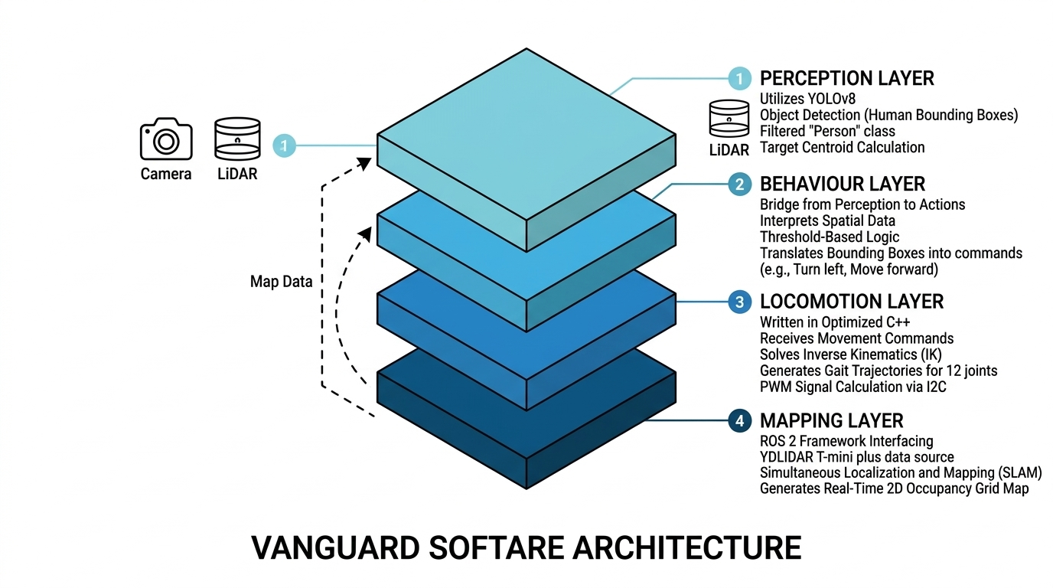
- Figure 4.1 Multilayer Architecture

4.1.1 Perception Layer
- The Perception Layer serves as the primary source of environmental intelligence for the VANGUARD platform. It utilizes a front-facing camera to feed a real-time computer vision pipeline powered by the YOLOv8 (You Only Look Once) neural network architecture. The primary objective of this layer is the identification and spatial localization of human targets within the robot's field of view. By filtering the inference results strictly for the "person" class, the system can calculate the relative distance and horizontal orientation of a subject based on the geometry and centroid of the detected bounding box. This continuous stream of visual data is essential for enabling semi-autonomous behaviours, allowing the robot to interact with its surroundings without constant manual intervention.

4.1.2 Behaviour Layer
- Acting as the decision-making bridge of the system, the Behaviour Layer interprets raw spatial data from the Perception Layer and translates it into high-level symbolic commands. Rather than streaming raw coordinates, which would increase computational overhead, this layer utilizes a threshold-based logic to categorize the robot’s environment. For instance, if a target’s bounding box shifts significantly toward the left edge of the frame, the Behaviour Layer generates a discrete 'l' (left) command. This abstraction layer is critical for maintaining high performance on edge hardware, as it simplifies the communication protocol between the Python-based vision stack and the C++ based hardware controller, ensuring a rapid response to dynamic environmental changes.

4.1.3 Locomotion Layer
- The Locomotion Layer represents the physical execution engine of the robot and is written in highly optimized C++ to ensure minimal latency. This layer is responsible for the complex mathematical task of Inverse Kinematics (IK), where it receives symbolic movement commands and calculates the exact joint angles (α, β ) required for each of the 12 servos to move the feet to specific coordinates. To produce fluid movement, the layer incorporates oscillator-based gait generation logic that sequences these foot trajectories over time, resulting in stable, periodic walking patterns. Finally, these calculated angles are converted into 12-bit PWM signals and transmitted via the I2C bus to a PCA9685 driver, which coordinates the simultaneous movement of the robot's 12 independent joints.

4.1.4 Mapping Layer
- The Mapping Layer provides the VANGUARD platform with spatial memory and situational awareness, facilitated by the ROS 2 framework. This layer interfaces directly with a YDLIDAR T-mini plus unit to perform Simultaneous Localization and Mapping (SLAM). Because the robot operates without traditional wheel odometry, the Mapping Layer relies on sophisticated "scan matching" algorithms. By comparing consecutive LiDAR sweeps and utilizing the Ceres solver for optimization, the system estimates the robot's displacement and rotation despite the inherent jitter of legged movement. This process culminates in the generation of a real-time 2D occupancy grid map, which serves as a foundation for future autonomous path planning and reconnaissance missions.

Mechanical Design and 12-DOF Structural Analysis

The physical architecture of the VANGUARD quadruped is engineered for high-fidelity maneuverability. The robot utilizes a "spider" or "mammalian" hybrid leg configuration, where each of the four legs is an independent 3-Degree-of-Freedom (DOF) kinematic chain.
- Hip Joint (Coxa): Responsible for horizontal rotation (abduction and adduction), allowing the robot to change its heading and perform lateral "strafing" movements.
- Thigh Joint (Femur): The primary vertical actuator that controls the reach and lift of the leg, determining the stride length.
- Knee Joint (Tibia): Works in synchronization with the femur to maintain the foot’s contact point relative to the ground and regulate the body’s height (Clearance).
The chassis is CNC-machined or high-density 3D printed to provide a rigid mounting surface for the Raspberry Pi . The mechanical assembly ensures that the center of mass is equidistant from all four leg attachment points, which is mathematically vital for the stability of the Inverse Kinematics solver. By maintaining this symmetry, the Locomotion Layer can distribute the robot’s weight evenly, reducing the torque requirements on individual servos during static standing and dynamic walking.

4.3. Electronics Architecture and Signal Integrity

The electronics suite is designed to bridge the gap between high-level digital logic and high-current analog actuation. The system is centered around the Raspberry Pi, which serves as the Master node in the I2C (Inter-Integrated Circuit) communication network.

- Communication Protocol: The Pi communicates with the PCA9685 16-channel PWM driver using the SDA (Serial Data) and SCL (Serial Clock) lines. The I2C address is typically set to 0x40. This offloads the generation of the 50Hz PWM signals from the Pi’s GPIO pins, ensuring that the timing of the pulses (ranging from 1ms to 2ms for servo positions) remains rock-solid even when the Pi’s CPU is under heavy load from YOLOv8 or ROS 2.

- Signal Conditioning: To prevent EMI (Electromagnetic Interference) and ground loops, the PWM signal lines are kept short, and twisted-pair wiring is used where possible to ensure that the 12-bit resolution of the PCA9685 translates to precise degree-level accuracy at the servo horns.

4.4 System Hardware and Servo Port Allocation

The physical realization of the VANGUARD quadruped requires a precise synchronization between high-speed digital logic and high-torque mechanical actuation. This chapter details the specific components selected for the system, their electrical characteristics, and the systemic interface architecture that allows the Raspberry Pi to control 12 independent degrees of freedom.

4.1 System Component Specifications
Table 4.1. Component Functioning
Components | Specification / Mode | Primary Function
Microcontroller | Raspberry Pi 4 Model B (4GB RAM) | Central processing for AI, SLAM, and Inverse Kinematics.
Servo Driver | PCA9685 16-Channel 12-bit PWM | I2C-based motor timing and signal generation.
Actuators | MG90S Metal Gear Micro Servos | 3-DOF per leg; provides torque for locomotion.
LiDAR Sensor | YDLIDAR T-mini Plus | 2D Laser scanning for environment mapping.
Camera | USB Endoscope Camera | Flexible, high-res visual feed for YOLOv8.
Power Source | 3x 18650 Li-ion Batteries | High-density 11.1V source for the main power rail.
Voltage Regulation | UBEC (Universal Battery Elimination Circuit) | 5V/3A low-noise regulation for RPi logic.

4.4.1. Circuit Architecture and Interfacing

The electronics architecture follows a strictly decoupled power strategy to ensure signal integrity and prevent system brownouts. The Raspberry Pi serves as the I2C Master, communicating via the Serial Data (SDA) and Serial Clock (SCL) lines to the PCA9685 driver.
The power distribution is managed through two distinct paths. A UBEC is employed to step down the 11.1V output from the 3-cell 18650 battery pack to a stable 5V, dedicated exclusively to the Raspberry Pi's logic. This high-efficiency regulation is crucial as it protects the Pi from the voltage fluctuations caused by the servos. The 12 MG90S servos draw their power directly from the battery rail (regulated or direct, depending on the specific voltage tolerance of your servos) via the PCA9685 terminal block. To ensure the PWM signals are interpreted correctly, a Common Ground is established between the UBEC output, the Raspberry Pi's GND pins, and the PCA9685 ground terminal.

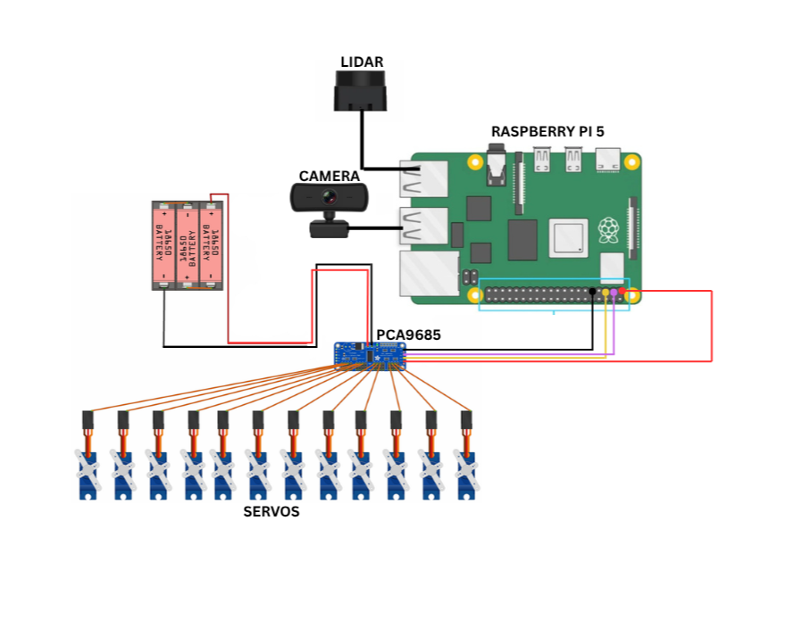
Figure 4.2 Circuit Diagram of the Quadruped System

4.4.2. Servo Pin Allocation and Channel Mapping

To maintain software modularity and facilitate the Inverse Kinematics (IK) calculations, the 12 servos are mapped to the PCA9685 channels in a consistent, leg-by-leg sequence.

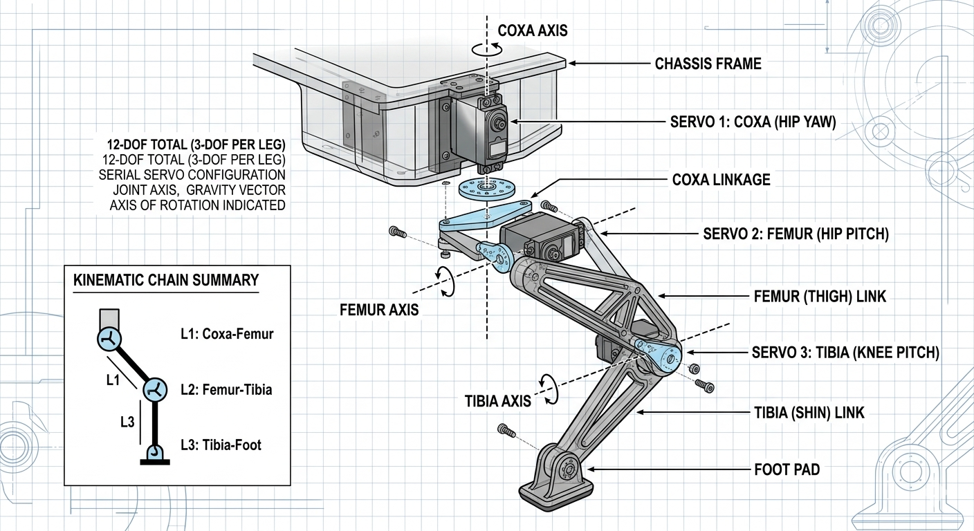
Figure 4.3 Servo Configurations in a Leg

4.2 Servo Allocation

Table 4.2. Servo to Driver Connections

Leg Identifier | Joint Type | PCA9685 Channel | RPi Connection
Leg 1 (Front Left) | Coxa, Femur, Tibia | 0, 1, 2 | I2C (Pins 2 & 3)
Leg 2 (Front Right) | Coxa, Femur, Tibia | 4, 5, 6 | I2C (Pins 2 & 3)
Leg 3 (Back Left) | Coxa, Femur, Tibia | 8, 9, 10 | I2C (Pins 2 & 3)
Leg 4 (Back Right) | Coxa, Femur, Tibia | 12, 13, 14 | I2C (Pins 2 & 3)

4.4.3. Specialized Sensor Integration

The sensor suite is integrated to provide the robot with a comprehensive understanding of its surroundings:

LiDAR Mapping: The YDLIDAR T-mini plus is interfaced via USB, streaming point cloud data directly to the ROS 2. Its central mounting position on the chassis ensures a 360-degree horizontal field of view.

Vision and Tracking: The USB Endoscope Camera is utilized for the perception layer. The flexible nature of the endoscope allows the lens to be positioned at an optimal "head" height for tracking human targets via YOLOv8, while the USB interface ensures high-speed data transfer to the Raspberry Pi for real-time inference.

4.4.4. Control System and Software

The heart of the movement system is our custom C++ IK solver. For each leg, the controller takes desired target coordinates (x, y, z) relative to the hip and calculates the required joint angles (α,β ). We implemented the following geometric and trigonometric relationships to solve for these angles based on the physical lengths of the leg segments (La, Lb, Lc) :

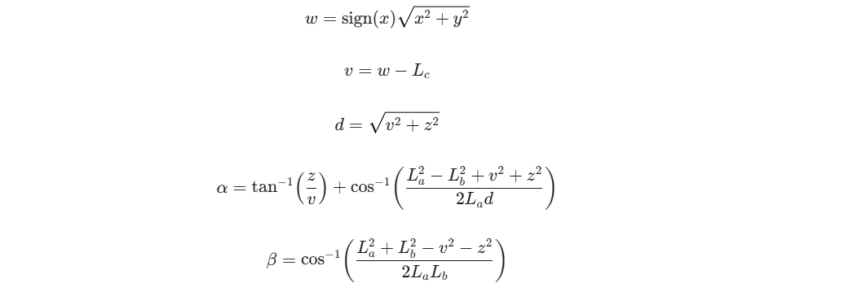

These mathematical outputs are processed, adjusted for physical servo orientations, and passed to our oscillator logic. This logic smoothly sequences the foot trajectories over time to generate stable, periodic walking gaits.
Because the robot currently relies on legged locomotion without joint encoders, standard wheel odometry data is unavailable. To overcome this, we heavily tuned the ROS 2 slam toolbox to operate purely on LiDAR scan matching. We configured the Ceres solver for robust matching and increased the scan queue size to handle the jitter
inherent in walking motions. By enabling TF restamping and utilizing an online asynchronous mapping mode, we successfully mitigated spatial drift and generated coherent 2D occupancy grids

CHAPTER 5
DEVELOPMENT EVOLUTION & SYSTEM TESTING

5.1. Phase 1: Prototype Development (8-DOF ESP32/Arduino)

The initial development of the VANGUARD platform focused on a simplified 8-Degree-of-Freedom (8-DOF) architecture. This prototype was designed to test the feasibility of a low-cost, micro-controller-based quadruped using an ESP32-CAM and an Arduino Nano.
- Hardware Configuration: 8 Micro-servos (2 per leg), ESP32-CAM for vision, and Arduino Nano for gait control.
- Workflow: The ESP32-CAM captured frames and streamed them to a local PC running OpenCV for human detection. The PC then sent directional commands back to the Arduino via a serial link.

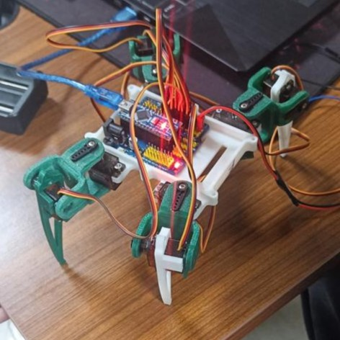
Figure 5.1 8-DOF Built Robot
5.1.1. Analysis of Prototype Limitations (The "Bottleneck" Effect)
During testing, the Phase 1 system exhibited several critical failures that rendered it inefficient for real-time search and rescue tasks:
- Processing Latency: The ESP32-CAM’s limited frame rate and the overhead of streaming video over Wi-Fi to a PC created a massive lag (approx. 500ms–1s). This meant the robot was reacting to where a person was, not where they are.

- Control Jitter: The Arduino Nano struggled to maintain high-frequency PWM signals while simultaneously parsing incoming serial commands, leading to jerky, unstable leg movements.

- Lack of Kinematic Depth: With only 2-DOF per leg, the robot lacked the "Coxa" (hip yaw) movement, making turning maneuvers slow and mechanically straining.

- Integration Failure: Attempting to run Human Detection, SLAM, and Locomotion simultaneously across separate microcontrollers led to synchronization errors.

5.2. Phase 2: The VANGUARD Upgrade (12-DOF Raspberry Pi 5)

To overcome the efficiency gap, the system was completely overhauled to the current Raspberry Pi 5 architecture described in Chapter 4. This move from a distributed microcontroller setup to a Single-Board Computer (SBC) centralized the "Brain," leading to the following improvements:

5.2.1 Centralized Processing: Raspberry Pi 5
The Raspberry Pi 5 revolutionized the system’s efficiency by handling three high-load tasks locally and in parallel:
- On-Device AI Inference: Running YOLOv8 at the edge eliminates Wi-Fi lag. The Pi 5 processes video at 30+ FPS, allowing for instantaneous reaction to human detection.
- Lidar SLAM Mapping: The Pi 5 processes 4,000 points/sec from the YDLIDAR T-mini via USB 3.0, generating real-time 2D maps for autonomous navigation.
- Complex Kinematics: The CPU solves the 3D Inverse Kinematics equations for all 12 joints simultaneously every 20ms.
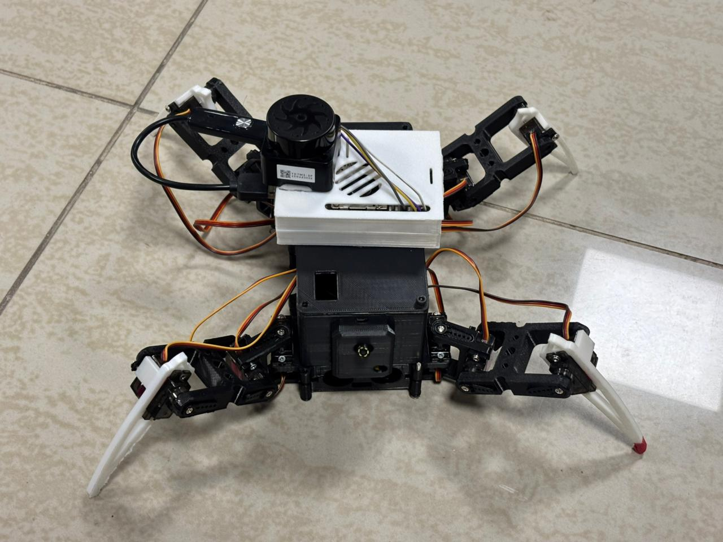
Figure 5.2 12-DOF Built Robot
5.2.2 The "Nervous System": I2C and PCA9685
Introduced hardware-level PWM offloading. The Pi 5 acts as the "Brain," sending position data via the I2C bus to the PCA9685 (the "Spinal Cord").
- Benefit: The PCA9685 maintains the servo pulses independently. Even if the Pi 5 is busy calculating a complex SLAM map, the legs move smoothly without jitter.
5.2.3 12-DOF Mobility and Inverse Kinematics (IK)
By adding the Coxa joint to each leg, the robot moved from 2D plane movement to 3D spatial movement.
- Omnidirectional Movement: The robot can now translate (move X/Y) and rotate (Yaw) simultaneously.
- Dynamic Stability: The 3-DOF configuration allows the robot to adjust its body height and tilt to compensate for uneven terrain while keeping the Lidar sensor level.
5.2.4 Perception and High-Speed Bus
Replaced the slow ESP32-CAM with a USB Endoscope Camera and a USB LiDAR.
- USB 3.0 Throughput: The Pi 5’s dedicated I/O controller allows for high-bandwidth data transfer, ensuring that the high-resolution video feed and Lidar point clouds do not compete for resources, maintaining a steady system heartbeat.

CHAPTER 6

FUTURE DEVELOPMENT
The current VANGUARD system is highly effective in ground-based navigation; however, its operational radius is limited by battery life and walking speed. To address this, the next phase of development focuses on the Aerial Carrier-Deployment Architecture, utilizing a VTOL platform equipped with a specialized winch mechanism for "Last-Mile" robotic delivery.
6.1 The VTOL Carrier Platform
To bridge the gap between long-range transit and localized exploration, a custom Fixed-Wing VTOL drone has been designed.
- Dual-Flight Mode: The drone utilizes four vertical rotors for precision take-off and landing in confined "Rescue Zones," transitioning to efficient fixed-wing flight for high-speed cruising.
- Aerodynamic Integration: The airframe is 3D-printed with high-tensile lightweight materials, featuring a central payload bay designed specifically to house the VANGUARD quadruped.
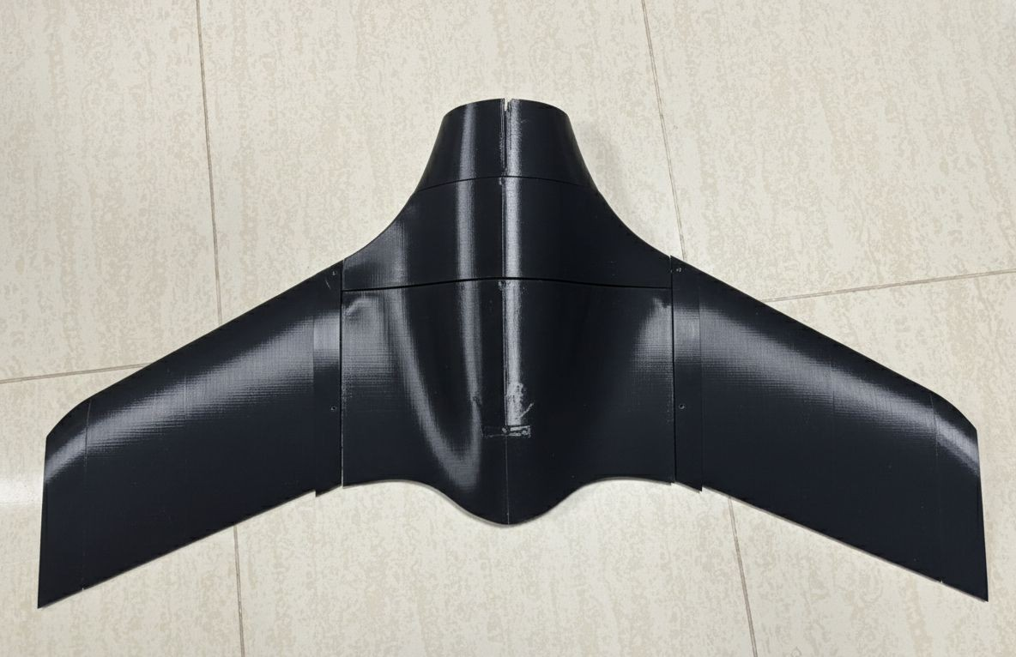
Figure 6.1 3D Printed Fuselage & Wings of VTOL

6.2 The Winch Deployment Mechanism
The core of the aerial-to-ground transition is the Automated Winch System. This allows the VTOL to hover at a safe altitude (away from debris or obstacles) while deploying the quadruped into the hot zone.
6.2.1 Mechanism Design
The winch utilizes a high-torque DC motor and a specialized spooling system. A magnetic or mechanical latching hook ensures that the quadruped remains securely fastened during high-speed aerial transit but can be released or retrieved with precision.
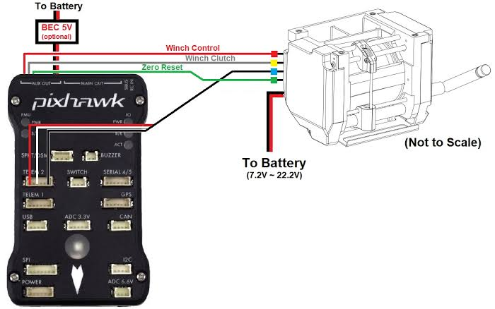
Figure 6.2 Connections between Winch & Flight Controller Pixhawk
6.2.2 Dedicated Winch Control PCB
To manage the high-current demands of the winch and ensure seamless communication with the flight controller, a custom-designed PCB has been developed.
- Pixhawk Integration: The PCB interfaces directly with the Pixhawk flight controller via the Telemetry or AUX ports, allowing the winch to be triggered by GPS-based mission commands.
- Safety Interlocks: The board includes current-sensing to detect if the quadruped has reached the ground or if the winch cable has reached its maximum tension, preventing motor burnout.
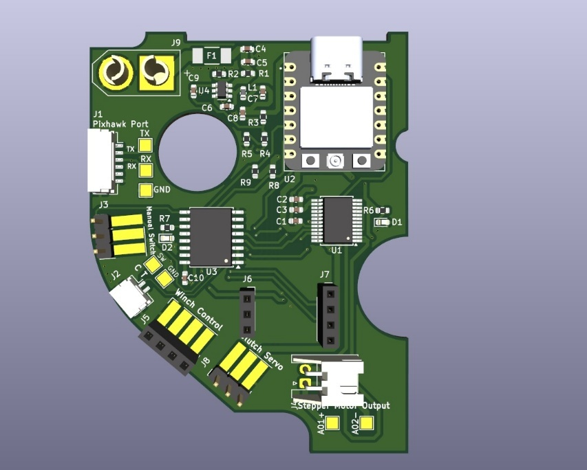
Figure 6.3 Custom made Winch PCB Board
6.3 Deployment Workflow (The "Carrier-Crawler" Loop)
The future operational workflow follows a five-stage sequence:
- Aerial Transit: VTOL carries VANGUARD in fixed-wing mode to a remote search area.
- VTOL Transition: The drone switches to hover mode over the target coordinates.
- Autonomous Deployment: The Winch PCB activates, lowering VANGUARD to the ground via a high-strength tether.
- Ground Operation: Once the quadruped detects ground contact, it detaches and begins its LiDAR/YOLOv8 mission.
- Retrieval: Upon mission completion, the VTOL lowers the hook; VANGUARD aligns itself using its vision system, and the winch lifts the robot back into the carrier bay for extraction.

And also in the system of VTOL instead of GPS, the drone’s navigation stack utilizes advanced Visual Odometry (VO). By fusing high-framerate camera data with low-latency IMU measurements, the system achieves robust real-time state estimation and spatial awareness.
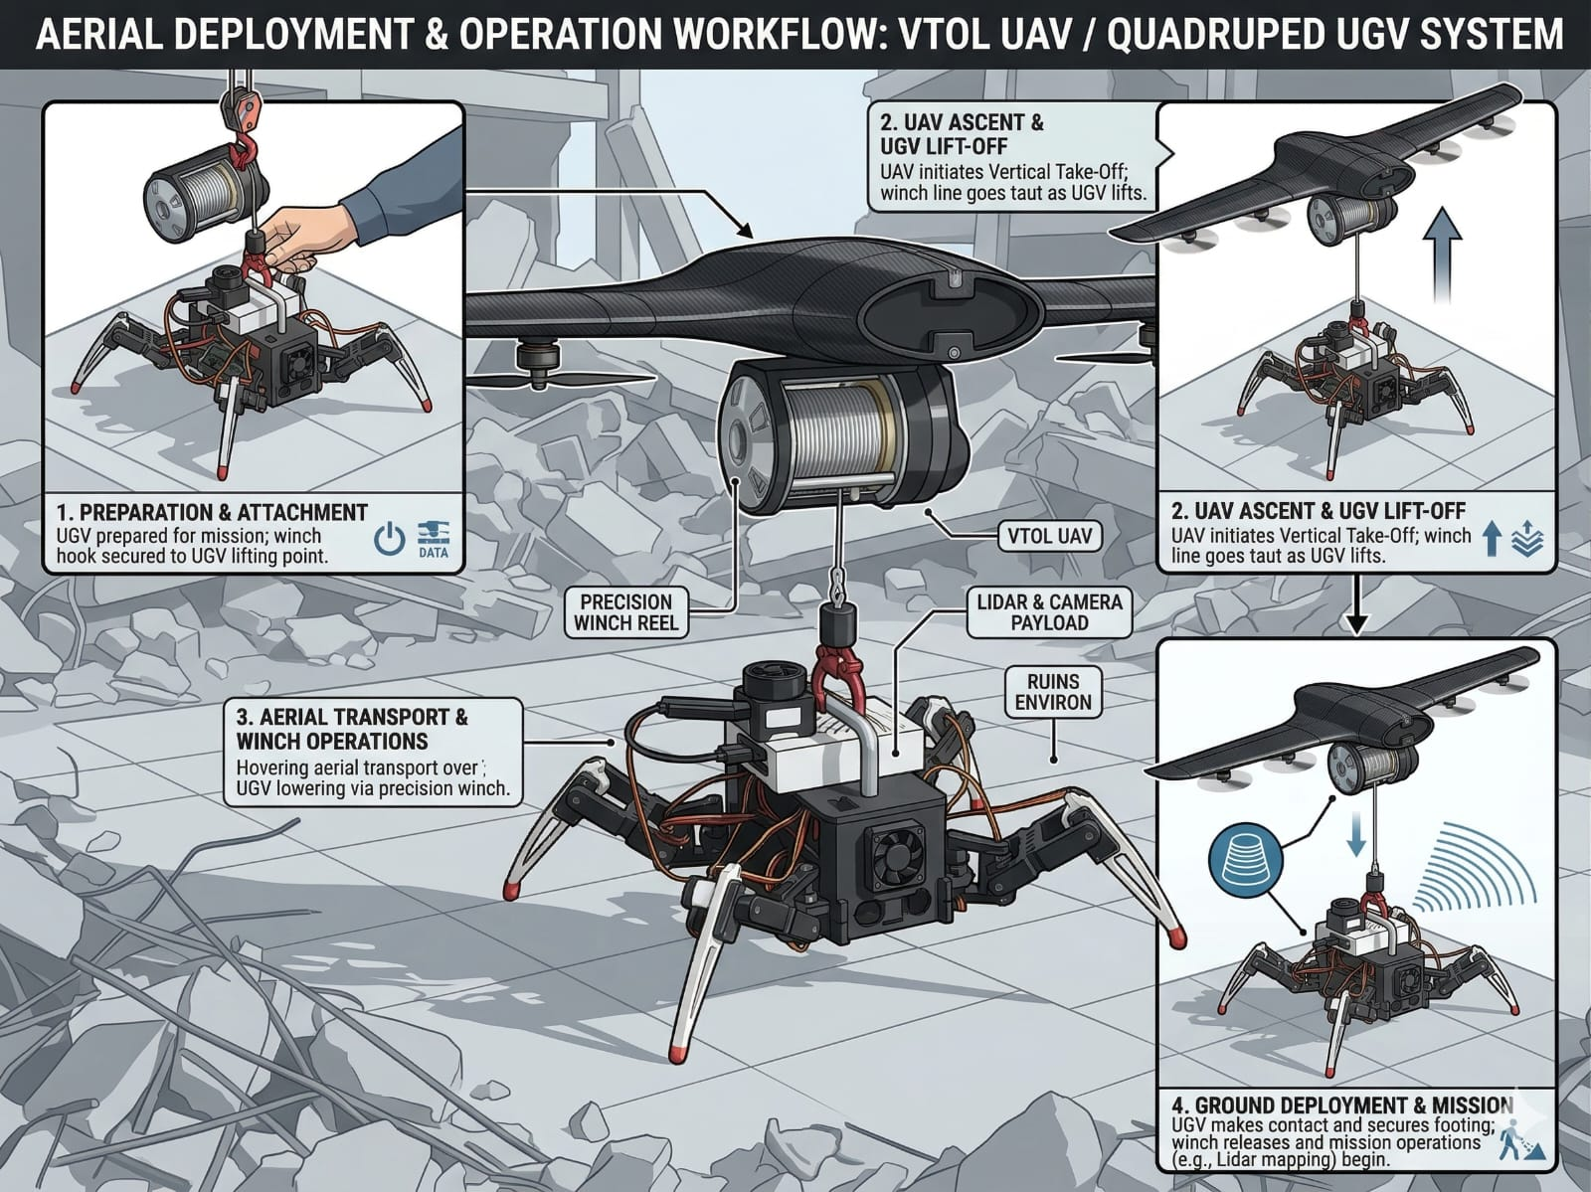
Figure 6.4 Depiction of how VTOL & Quadruped would work together
Furthermore, the hybrid VTOL aerodynamic design allows the aircraft to take off vertically in con strained spaces and seamlessly transition into fixed-wing forward flight. This aerodynamic efficiency yields a drastically increased flight time and operational range compared to conventional multirotor drones currently in existence, making it highly suitable for extended reconnaissance and mapping missions.

CHAPTER 7

CONCLUSION
The development of the VANGUARD Quadrupedal System represents a significant engineering evolution from a basic 8-DOF prototype to a high-performance, autonomous robotic platform. Initially, the project utilized an ESP32-CAM and Arduino Nano architecture, which served as a critical learning phase; however, testing revealed severe bottlenecks, including high vision latency, serial communication lag, and a lack of lateral mobility.

To overcome these limitations, the system was overhauled to a Phase 2 architecture centered around the Raspberry Pi 5. This upgrade centralized processing, allowing for local, real-time YOLOv8n human detection at 30+ FPS and simultaneous LiDAR-based SLAM mapping via the YDLIDAR T-mini. By integrating a 12-DOF Inverse Kinematics (IK) model and offloading PWM generation to a PCA9685 driver over I2C, VANGUARD achieved fluid, omnidirectional locomotion and dynamic stability. The transition to a 3S 11.1V Li-Ion power strategy with a dedicated 5V/5A UBEC ensured that high-torque maneuvers did not compromise the integrity of the logic rail.

Looking toward future deployment, the system is designed to integrate with a custom Fixed-Wing VTOL carrier. This aerial platform utilizes Visual Odometry (VO) and IMU fusion for GPS-independent navigation, transitioning from vertical takeoff to efficient forward flight. A specialized Winch Mechanism, controlled by a custom-designed PCB and integrated with a Pixhawk flight controller, allows for the precise deployment and retrieval of the quadruped in high-risk zones. Ultimately, VANGUARD demonstrates that the fusion of advanced edge computing, complex 3D kinematics, and multi-domain aerial coordination can create a robust, rapidly deployable solution for next-generation search and rescue operations.

REFERENCES

- P. Čížek, M. Zoula, J. Faigl, "Design, Construction, and Rough-Terrain Locomotion Control of Novel Hexapod Walking Robot With Four Degrees of Freedom Per Leg", IEEE Access, Vol. 9, 2021.
- T. Karakurt, A. Durdu, N. Yilmaz, "Design of Six Legged Spider Robot and Evolving Walking Algorithms", International Journal of Machine Learning and Computing, Vol. 5, No. 2, 2015.
- M. P. Manuel, M. Faied, M. Krishnan, "A LoRa-Based Disaster Management System for Search and Rescue Mission", IEEE Internet of Things Journal, Vol. 11, No. 20, 2024.
- J. Li, G. Yang, Q. Cai, "Autonomous Aerial-Ground Cooperative Navigation Based on Information-Seeking in GNSS-Denied Environments", IEEE Internet of Things Journal, 2023.
- L. Abraham, J. Jose, S. Biju, R. Kalantri, F. Biju, S. Rajguru, "Swarm Robotics in Disaster Management", International Conference on Emerging Technologies, 2019.
- M. Hutter, C. Gehring, D. Jud, A. Lauber, C. D. Bellicoso, V. Tsounis, J. Hwangbo, K. Bodie, P. Fankhauser, M. Bloesch, R. Diethelm, S. Bachmann, A. Melzer, M. Hoepflinger, "ANYmal - A Highly Mobile and Dynamic Quadrupedal Robot", IEEE/RSJ International Conference on Intelligent Robots and Systems (IROS), 2016.
- C. D. Bellicoso, F. Jenelten, C. Gehring, M. Hutter, "Dynamic Locomotion and Whole-Body Control for Quadrupedal Robots", IEEE International Conference on Robotics and Automation (ICRA), 2017.
- M. Bjelonic, N. Kottege, P. Beckerle, "Proprioceptive Control of an Over-Actuated Hexapod Robot in Unstructured Terrain", IEEE/RSJ International Conference on Intelligent Robots and Systems (IROS), 2016.
- S. Khattak, C. Papachristos, K. Alexis, "Keyframe-based Thermal-Inertial Odometry for Autonomous Navigation of MAVs in GNSS-Denied Environments", IEEE International Conference on Robotics and Automation (ICRA), 2019.
- F. Meyer, H. Wymeersch, M. Fröhle, F. Hlawatsch, "Distributed Estimation with Information-Seeking Control in Agent Networks", IEEE Journal on Selected Areas in Communications, Vol. 33, No. 11, 2015.
- R. O. Guerrero, G. T. M. D’Angelo, D. S. L. L. L. L. L., "Petri Net-Based Modeling and Control of Humanoid Robot Walking Gait", IEEE Transactions on Systems, Man, and Cybernetics: Systems, Vol. 50, No. 7, 2020.
- A. Breitenmoser, F. T. S. T. S., R. Siegwart, "Robust Communication for Multi Robot Systems in Unstructured Environments", IEEE Robotics and Automation Letters, Vol. 3, No. 4, 2018.
- P. Deeg, C. A. Boano, M. A. M. A., K. Römer, "A LoRa-Based Meshed IoT Network for Live Monitoring of Glacier Dynamics", ACM Transactions on Sensor Networks, Vol. 18, No. 3, 2022.
- J. Delmerico, E. Mueggler, J. N. N. J., D. Scaramuzza, "Active Autonomous Aerial Exploration for Ground Robot Path Planning", IEEE Robotics and Automation Letters, Vol. 2, No. 2, 2017.
- K. Walas, D. Kanoulas, M. G. M. G., "Vision-Based Human Detection for Robotic Search and Rescue", Journal of Field Robotics, Vol. 36, No. 5, 2019
- U. Saranli, M. Buehler, D. E. Koditschek, "RHex: A Simple and Highly Mobile Hexapod Robot", The International Journal of Robotics Research, Vol. 20, No. 7, 2001.
- K. Berns, V. Kepplin, W. Ilg, R. Dillmann, "Experiments with a Stereo Camera Head for the Local Navigation of LAURON III", Forschungszentrum Informatik (FZI), Karlsruhe, Germany, 1993
- B. L. Luk, D. S. Cooke, S. Galt, A. A. Collie, S. Chen, "Intelligent Legged Climbing Service Robot for Remote Maintenance Applications in Hazardous Environments", Robotics and Autonomous Systems, Vol. 53, 2005.
- R. D. Quinn, K. S. Espenschied, "Control of a Hexapod Robot Using a Biologically Inspired Neural Network", in Biological Neural Networks in Invertebrate Neuroethology and Robotics, R. D. Beer, R. E. Ritzmann, T. M. McKenna, Eds., Academic Press, 1993.
- D. Belter, P. Skrzypczyński, "Integrated Motion Planning for a Hexapod Robot Walking on Rough Terrain", IFAC Proceedings Volumes, Vol. 44, No. 1, 2011.
- J. Faigl, P. Čížek, "Adaptive Locomotion Control of Hexapod Walking Robot for Traversing Rough Terrains with Position Feedback Only", Robotics and Autonomous Systems, Vol. 116, 2019.
- A. Roennau, G. Heppner, M. Nowicki, R. Dillmann, "LAURON V: A Versatile Six-Legged Walking Robot with Advanced Maneuverability", IEEE/ASME International Conference on Advanced Intelligent Mechatronics (AIM), 2014.
- J. Terven and D. Cordova-Esparza, "A Comprehensive Review of YOLO: From YOLOv1 to YOLOv8 and Beyond," arXiv preprint arXiv:2304.00501, 2023.
- S. Cass, "The Raspberry Pi 5: The Benchmark for Single-Board Computers," IEEE Spectrum, vol. 45, no. 11, 2023.
- M. A. Sen, V. Bakircioglu, and M. Kalyoncu, "Inverse Kinematics Analysis and Gait Planning for a Quadruped Robot," International Journal of Mechanical Engineering and Robotics Research, vol. 10, no. 10, 2021.
- D. Scaramuzza and F. Fraundorfer, "Visual Odometry: Part I: The First 30 Years and Fundamentals," IEEE Robotics & Automation Magazine, vol. 18, no. 4, 2011.
- A. R. Mora, et al., "Towards Autonomous Tethered Landing of a UAV on a Moving Platform," IEEE Robotics and Automation Letters, vol. 7, no. 2, 2022.
- NXP Semiconductors, "PCA9685: 16-channel, 12-bit PWM Fm+ I2C-bus LED Controller Product Data Sheet," Rev. 4, 2015.
- C. Cadena, et al., "Past, Present, and Future of Simultaneous Localization and Mapping: Toward the Robust-Perception Age," IEEE Transactions on Robotics, vol. 32, no. 6, 2016.
- R. R. Murphy, Disaster Robotics, MIT Press, 2014.
APPENDIX

MAIN LOGIC SYSTEM FUNCTIONING

#include "Vanguard.h"
#include "Compat.h"

#include <algorithm>
#include <cctype>
#include <cstdio>
#include <cstdlib>
#include <string>
#include <sys/select.h>
#include <unistd.h>

// Dictionary copied from Arduino Mark-2 logic.
#define FORWARD 'f'
#define BACKWARD 'b'
#define LEFT 'l'
#define RIGHT 'r'
#define STOP 's'
#define SIT 'i'

#define HEIGHTUP 'u'
#define HEIGHTDOWN 'v'

#define MOVEFORWARD 'w'
#define MOVEBACKWARD 'x'
#define MOVELEFT 'a'
#define MOVERIGHT 'd'

#define HANDWAVE 'e'
#define HANDSHAKE 'g'
#define DRIVEMODE 'h'

namespace {
Vanguard vanguard;

bool state = true;
char cmd = STOP;
bool check_service = false;
bool quit_requested = false;

float gait_period_ms = 520.0f;
int height_percent = 62;
std::string serial_buffer;

std::string trimLower(const std::string& raw) {
std::string out = raw;
std::transform(out.begin(), out.end(), out.begin(),
[](unsigned char c) { return static_cast<char>(std::tolower(c)); });

auto is_space = [](unsigned char c) { return std::isspace(c) != 0; };
while (!out.empty() && is_space(static_cast<unsigned char>(out.front()))) {
out.erase(out.begin());
}
while (!out.empty() && is_space(static_cast<unsigned char>(out.back()))) {
out.pop_back();
}
return out;
}

bool startsWith(const std::string& value, const std::string& prefix) {
return value.rfind(prefix, 0) == 0;
}

bool parsePrefixedInt(const std::string& value, const std::string& prefix, int& out) {
if (!startsWith(value, prefix)) {
return false;
}

const std::string num = value.substr(prefix.size());
if (num.empty()) {
return false;
}

char* end = nullptr;
const long parsed = std::strtol(num.c_str(), &end, 10);
if (end == num.c_str() || *end != '\0') {
return false;
}

out = static_cast<int>(parsed);
return true;
}

void adjustHeightStep(bool up) {
if (up) {
height_percent += 5;
} else {
height_percent -= 5;
}
height_percent = constrain(height_percent, 0, 100);
vanguard.adjustHeight(height_percent);
}

bool gaits(char current_cmd) {
bool taken = true;
switch (current_cmd) {
case FORWARD:
vanguard.walk(1, 1, gait_period_ms);
break;
case BACKWARD:
vanguard.walk(0, 1, gait_period_ms);
break;
case RIGHT:
vanguard.turnR(1, gait_period_ms);
break;
case LEFT:
vanguard.turnL(1, gait_period_ms);
break;
case STOP:
vanguard.home();
break;
case SIT:
vanguard.sit();
break;
case MOVEFORWARD:
// Pi build has no wheel pins, so wheel commands map to body gait commands.
vanguard.walk(1, 1, gait_period_ms);
break;
case MOVEBACKWARD:
vanguard.walk(0, 1, gait_period_ms);
break;
case MOVELEFT:
vanguard.turnL(1, gait_period_ms);
break;
case MOVERIGHT:
vanguard.turnR(1, gait_period_ms);
break;
case HANDWAVE:
vanguard.hello(700);
break;
case HANDSHAKE:
vanguard.hello(1100);
break;
case HEIGHTUP:
adjustHeightStep(true);
taken = false;
break;
case HEIGHTDOWN:
adjustHeightStep(false);
taken = false;
break;
case DRIVEMODE:
vanguard.wheelmode();
taken = false;
break;
default:
taken = false;
}
return taken;
}

void handleCommandLine(const std::string& raw_line) {
const std::string command = trimLower(raw_line);
if (command.empty()) {
return;
}

if (command == "f") cmd = FORWARD;
else if (command == "b") cmd = BACKWARD;
else if (command == "l") cmd = LEFT;
else if (command == "r") cmd = RIGHT;
else if (command == "s") cmd = STOP;
else if (command == "w") cmd = MOVEFORWARD;
else if (command == "x") cmd = MOVEBACKWARD;
else if (command == "a") cmd = MOVELEFT;
else if (command == "d") cmd = MOVERIGHT;
else if (command == "h") cmd = DRIVEMODE;
else if (command == "u") adjustHeightStep(true);
else if (command == "v") adjustHeightStep(false);
else {
int value = 0;
if (parsePrefixedInt(command, "xd,", value)) {
(void)value;
} else if (parsePrefixedInt(command, "yd,", value)) {
(void)value;
} else if (parsePrefixedInt(command, "zd,", value)) {
const int mapped_percent = static_cast<int>(map(value, -85, -45, 0, 100));
height_percent = constrain(mapped_percent, 0, 100);
vanguard.adjustHeight(height_percent);
} else if (parsePrefixedInt(command, "ls,", value)) {
if (value > 0) {
gait_period_ms = constrain(520.0f * (8.0f / static_cast<float>(value)), 180.0f, 2000.0f);
}
} else if (parsePrefixedInt(command, "ss,", value)) {
(void)value;
}
}
}

void serialEvent() {
while (true) {
fd_set readfds;
FD_ZERO(&readfds);
FD_SET(STDIN_FILENO, &readfds);
timeval tv = {0, 0};
const int ready = select(STDIN_FILENO + 1, &readfds, nullptr, nullptr, &tv);
if (ready <= 0 || !FD_ISSET(STDIN_FILENO, &readfds)) {
break;
}

char c = '\0';
const ssize_t n = read(STDIN_FILENO, &c, 1);
if (n <= 0) {
break;
}

state = !state;
if (c == '\r') {
continue;
}
if (c == '\n') {
handleCommandLine(serial_buffer);
serial_buffer.clear();
continue;
}

serial_buffer.push_back(c);
if (serial_buffer.size() > 128) {
serial_buffer.clear();
}
}
}
} // namespace

int main() {
vanguard.init();
delay(300);
vanguard.home();

while (!quit_requested) {
serialEvent();
gaits(cmd);
}

vanguard.home();
(void)check_service;
(void)state;
return 0;
}

LIDAR MAPPING

#!/usr/bin/env python3
import argparse
import glob
import math
import sys
import threading
import time
from pathlib import Path

import cv2
import serial
from ultralytics import YOLO

CMD_FORWARD = "f\n"
CMD_LEFT = "l\n"
CMD_RIGHT = "r\n"
CMD_STOP = "s\n"

class LidarScanGuard:
def __init__(
self,
scan_topic="/scan",
front_half_angle_deg=20.0,
side_min_angle_deg=25.0,
side_max_angle_deg=95.0,
):
try:
import rclpy
from rclpy.node import Node
from sensor_msgs.msg import LaserScan
except ImportError as exc:
raise RuntimeError(
"LiDAR obstacle mode requires ROS2 Python packages (rclpy, sensor_msgs). "
"Source ROS env and/or install ros-jazzy-rclpy + ros-jazzy-sensor-msgs."
) from exc

self._rclpy = rclpy
self._LaserScan = LaserScan
self._scan_topic = scan_topic
self._front_half_angle_deg = float(front_half_angle_deg)
self._side_min_angle_deg = float(side_min_angle_deg)
self._side_max_angle_deg = float(side_max_angle_deg)
self._lock = threading.Lock()
self._latest = None
self._running = True
self._rclpy_inited_here = False

if not self._rclpy.ok():
self._rclpy.init(args=None)
self._rclpy_inited_here = True

class _Node(Node):
pass

self._node = _Node("human_follow_lidar_guard")
self._sub = self._node.create_subscription(
self._LaserScan, self._scan_topic, self._on_scan, 10
)
self._spin_thread = threading.Thread(target=self._spin_loop, daemon=True)
self._spin_thread.start()

@property
def scan_topic(self):
return self._scan_topic

def _spin_loop(self):
while self._running and self._rclpy.ok():
self._rclpy.spin_once(self._node, timeout_sec=0.1)

def _on_scan(self, msg):
# Keep only minimal fields needed for clearance checks.
with self._lock:
self._latest = {
"t": time.time(),
"angle_min": float(msg.angle_min),
"angle_increment": float(msg.angle_increment),
"range_min": float(msg.range_min),
"range_max": float(msg.range_max),
"ranges": list(msg.ranges),
}

@staticmethod
def _sector_min(data, deg_min, deg_max):
angle_min = data["angle_min"]
angle_increment = data["angle_increment"]
range_min = data["range_min"]
range_max = data["range_max"]
ranges = data["ranges"]

if not ranges or angle_increment == 0.0:
return float("inf")

best = float("inf")
for i, r in enumerate(ranges):
if not math.isfinite(r):
continue
if r < range_min or r > range_max:
continue
deg = math.degrees(angle_min + i * angle_increment)
if deg < deg_min or deg > deg_max:
continue
if r < best:
best = r
return best

def get_clearance(self):
with self._lock:
data = self._latest

if data is None:
return None

front = self._sector_min(data, -self._front_half_angle_deg, self._front_half_angle_deg)
left = self._sector_min(data, self._side_min_angle_deg, self._side_max_angle_deg)
right = self._sector_min(data, -self._side_max_angle_deg, -self._side_min_angle_deg)
age = time.time() - data["t"]
return {"front": front, "left": left, "right": right, "age": age}

def close(self):
self._running = False
if hasattr(self, "_spin_thread") and self._spin_thread.is_alive():
self._spin_thread.join(timeout=0.3)
if hasattr(self, "_node"):
self._node.destroy_node()
if self._rclpy_inited_here and self._rclpy.ok():
self._rclpy.shutdown()

def apply_lidar_guard(cmd, reason, clearance, stale_timeout_s, forward_stop_m, side_stop_m):
if clearance is None:
return cmd, reason + "|obs-no-scan"
if clearance["age"] > stale_timeout_s:
return cmd, reason + "|obs-stale"

front = clearance["front"]
left = clearance["left"]
right = clearance["right"]

if cmd == CMD_FORWARD and front < forward_stop_m:
if left >= side_stop_m and left >= right:
return CMD_LEFT, reason + "|obs-front-left"
if right >= side_stop_m:
return CMD_RIGHT, reason + "|obs-front-right"
return CMD_STOP, reason + "|obs-front-stop"

if cmd == CMD_LEFT and left < side_stop_m:
if right >= side_stop_m:
return CMD_RIGHT, reason + "|obs-left-blocked"
return CMD_STOP, reason + "|obs-left-stop"

if cmd == CMD_RIGHT and right < side_stop_m:
if left >= side_stop_m:
return CMD_LEFT, reason + "|obs-right-blocked"
return CMD_STOP, reason + "|obs-right-stop"

return cmd, reason

def load_yaml_config(config_path):
if not config_path:
return {}

path = Path(config_path).expanduser()
if not path.exists():
return {}

try:
import yaml
except ImportError as exc:
raise SystemExit(
f"Config file found at {path}, but PyYAML is missing. Install with: "
"python3 -m pip install pyyaml"
) from exc

with path.open("r", encoding="utf-8") as f:
data = yaml.safe_load(f) or {}

if not isinstance(data, dict):
raise SystemExit(f"Config file must contain a YAML mapping/object: {path}")

return data

def cfg_get(cfg, *keys, default=None):
cur = cfg
for key in keys:
if not isinstance(cur, dict) or key not in cur:
return default
cur = cur[key]
return cur

def find_serial_port(preferred=None):
candidates = sorted(glob.glob("/dev/ttyUSB*") + glob.glob("/dev/ttyACM*"))
if preferred:
if Path(preferred).exists():
return preferred
if candidates:
print(f"Requested port {preferred} not found, using {candidates[0]} instead")
return candidates[0]
return None
return candidates[0] if candidates else None

def pick_target(boxes_xyxy, confs, min_area):
best = None
best_area = 0
best_conf = 0.0
for box, conf in zip(boxes_xyxy, confs):
x1, y1, x2, y2 = box
w = max(0, int(x2 - x1))
h = max(0, int(y2 - y1))
area = w * h
if area < min_area:
continue
if area > best_area:
best = (int(x1), int(y1), int(x2), int(y2))
best_area = area
best_conf = float(conf)
return best, best_area, best_conf

def command_for_target(frame_w, target, area, close_area, target_px):
if target is None:
return CMD_STOP, "no-target", None
x1, _, x2, _ = target
cx = (x1 + x2) / 2.0
dx = cx - (frame_w / 2.0)
if area >= close_area:
return CMD_STOP, "close", dx
if dx < -target_px:
return CMD_LEFT, "turn-left", dx
if dx > target_px:
return CMD_RIGHT, "turn-right", dx
return CMD_FORWARD, "forward", dx

def main():
p = argparse.ArgumentParser(description="Follow a person using YOLO + USB serial control")
default_config = Path(__file__).resolve().parents[1] / "config" / "human_follow.yaml"
p.add_argument(
"--config",
type=str,
default=str(default_config),
help="YAML config file for follow/search behavior",
)
p.add_argument("--source", type=str, default="0", help="camera index or video path")
p.add_argument("--port", help="serial port, e.g. /dev/ttyUSB0")
p.add_argument("--baud", type=int, default=115200)
p.add_argument("--weights", type=str, default="yolov8n.pt")
p.add_argument("--device", type=str, default="cpu")
p.add_argument("--imgsz", type=int, default=256)
p.add_argument("--cam-width", type=int, default=640)
p.add_argument("--cam-height", type=int, default=360)
p.add_argument("--proc-width", type=int, default=640)
p.add_argument("--proc-height", type=int, default=360)
p.add_argument("--conf", type=float, default=0.35)
p.add_argument("--iou", type=float, default=0.50)
p.add_argument("--min-area", type=int, default=2500)
# Stop only when the person bbox becomes very large (i.e., robot is closer).
p.add_argument("--close-area", type=int, default=95000)
p.add_argument("--target-px", type=int, default=35)
p.add_argument("--process-every", type=int, default=3)
p.add_argument("--send-interval", type=float, default=0.20)
p.add_argument(
"--robot-speed-ls",
type=int,
default=8,
help="Speed value sent as ls,<value> to vanguard_pi (higher is faster)",
)
p.add_argument(
"--search-enabled",
action=argparse.BooleanOptionalAction,
default=True,
help="enable/disable rotate search when no human is detected",
)
p.add_argument(
"--search-rotate-seconds",
type=float,
default=5.0,
help="target cycle time for one search rotation when no human is detected",
)
p.add_argument(
"--search-direction",
type=str,
default="left",
choices=["left", "right"],
help="rotation direction in search mode (no human detected)",
)
p.add_argument(
"--obstacle-mode",
type=str,
default="off",
choices=["off", "on"],
help="LiDAR obstacle override mode (off/on)",
)
p.add_argument("--scan-topic", type=str, default="/scan", help="ROS2 LaserScan topic")
p.add_argument("--obstacle-forward-stop-m", type=float, default=0.50)
p.add_argument("--obstacle-side-stop-m", type=float, default=0.35)
p.add_argument("--obstacle-stale-timeout-s", type=float, default=0.80)
p.add_argument("--obstacle-front-half-angle-deg", type=float, default=20.0)
p.add_argument("--obstacle-side-min-angle-deg", type=float, default=25.0)
p.add_argument("--obstacle-side-max-angle-deg", type=float, default=95.0)
p.add_argument("--show", action="store_true")
p.add_argument(
"--stdout-cmd",
action="store_true",
help="write only f/l/r/s commands to stdout instead of serial (for piping into vanguard_pi)",
)
args = p.parse_args()

cfg = load_yaml_config(args.config)
if cfg:
args.robot_speed_ls = int(cfg_get(cfg, "motion", "robot_speed_ls", default=args.robot_speed_ls))
args.search_enabled = bool(cfg_get(cfg, "search", "enabled", default=args.search_enabled))
args.search_rotate_seconds = float(
cfg_get(cfg, "search", "rotate_seconds", default=args.search_rotate_seconds)
)
cfg_dir = str(cfg_get(cfg, "search", "direction", default=args.search_direction)).lower()
if cfg_dir in ("left", "right"):
args.search_direction = cfg_dir
args.send_interval = float(cfg_get(cfg, "follow", "send_interval", default=args.send_interval))
cfg_obs_mode = str(cfg_get(cfg, "obstacle", "mode", default=args.obstacle_mode)).lower()
if cfg_obs_mode in ("off", "on"):
args.obstacle_mode = cfg_obs_mode
args.scan_topic = str(cfg_get(cfg, "obstacle", "scan_topic", default=args.scan_topic))
args.obstacle_forward_stop_m = float(
cfg_get(cfg, "obstacle", "forward_stop_m", default=args.obstacle_forward_stop_m)
)
args.obstacle_side_stop_m = float(
cfg_get(cfg, "obstacle", "side_stop_m", default=args.obstacle_side_stop_m)
)
args.obstacle_stale_timeout_s = float(
cfg_get(cfg, "obstacle", "stale_timeout_s", default=args.obstacle_stale_timeout_s)
)
args.obstacle_front_half_angle_deg = float(
cfg_get(
cfg,
"obstacle",
"front_half_angle_deg",
default=args.obstacle_front_half_angle_deg,
)
)
args.obstacle_side_min_angle_deg = float(
cfg_get(
cfg,
"obstacle",
"side_min_angle_deg",
default=args.obstacle_side_min_angle_deg,
)
)
args.obstacle_side_max_angle_deg = float(
cfg_get(
cfg,
"obstacle",
"side_max_angle_deg",
default=args.obstacle_side_max_angle_deg,
)
)

ser = None
if not args.stdout_cmd:
port = find_serial_port(args.port)
if not port:
raise SystemExit("No serial device found. Check with: ls /dev/ttyUSB* /dev/ttyACM*")
ser = serial.Serial(port, baudrate=args.baud, timeout=0.05)
print(f"Using serial port: {port}")
time.sleep(2.0)
ser.reset_input_buffer()
else:
print("Using stdout command mode (pipe into vanguard_pi)", file=sys.stderr)

src = int(args.source) if args.source.isdigit() else args.source
cap = cv2.VideoCapture(src)
if not cap.isOpened():
raise SystemExit(f"Could not open source: {args.source}")
if args.cam_width > 0:
cap.set(cv2.CAP_PROP_FRAME_WIDTH, args.cam_width)
if args.cam_height > 0:
cap.set(cv2.CAP_PROP_FRAME_HEIGHT, args.cam_height)

model = YOLO(args.weights)

speed_value = max(1, int(args.robot_speed_ls))
speed_cmd = f"ls,{speed_value}\n"
if args.stdout_cmd:
# In pipe mode this reaches vanguard_pi stdin directly.
sys.stdout.write(speed_cmd)
sys.stdout.flush()
print(f"speed-init ls={speed_value}", file=sys.stderr)
else:
ser.write(speed_cmd.encode("ascii"))
print(f"speed-init ls={speed_value}")

lidar_guard = None
if args.obstacle_mode == "on":
lidar_guard = LidarScanGuard(
scan_topic=args.scan_topic,
front_half_angle_deg=args.obstacle_front_half_angle_deg,
side_min_angle_deg=args.obstacle_side_min_angle_deg,
side_max_angle_deg=args.obstacle_side_max_angle_deg,
)
print(
f"obstacle-mode=on topic={lidar_guard.scan_topic} "
f"forward_stop={args.obstacle_forward_stop_m:.2f}m side_stop={args.obstacle_side_stop_m:.2f}m",
file=sys.stderr if args.stdout_cmd else sys.stdout,
)
else:
print("obstacle-mode=off", file=sys.stderr if args.stdout_cmd else sys.stdout)

frame_idx = 0
last_target = None
last_area = 0
last_conf = 0.0
last_cmd = None
last_send = 0.0
search_cycle_start = time.time()
search_cmd = CMD_LEFT if args.search_direction == "left" else CMD_RIGHT

try:
while True:
ok, frame = cap.read()
if not ok:
time.sleep(0.03)
continue

frame_idx += 1
h, w = frame.shape[:2]

if ((frame_idx - 1) % max(1, args.process_every)) == 0:
proc = cv2.resize(frame, (args.proc_width, args.proc_height))
sx = w / float(args.proc_width)
sy = h / float(args.proc_height)

res = model.predict(
source=proc,
imgsz=args.imgsz,
conf=args.conf,
iou=args.iou,
verbose=False,
device=args.device
)[0]

if res.boxes is not None and len(res.boxes) > 0:
boxes = res.boxes.xyxy.cpu().numpy()
clss = res.boxes.cls.cpu().numpy().astype(int)
confs = res.boxes.conf.cpu().numpy()

person_boxes = []
person_confs = []
for b, c, cf in zip(boxes, clss, confs):
if c == 0:
x1, y1, x2, y2 = b
person_boxes.append([x1 * sx, y1 * sy, x2 * sx, y2 * sy])
person_confs.append(cf)
last_target, last_area, last_conf = pick_target(person_boxes, person_confs, args.min_area)
else:
last_target, last_area, last_conf = None, 0, 0.0

now = time.time()
if last_target is None:
if args.search_enabled:
elapsed = now - search_cycle_start
if elapsed >= max(0.1, args.search_rotate_seconds):
search_cycle_start = now
elapsed = 0.0
cmd = search_cmd
reason = f"search-{args.search_direction}-{elapsed:.1f}s"
else:
cmd = CMD_STOP
reason = "no-target-stop"
dx = None
else:
search_cycle_start = now
cmd, reason, dx = command_for_target(
w, last_target, last_area, args.close_area, args.target_px
)

clearance = None
if lidar_guard is not None:
clearance = lidar_guard.get_clearance()
cmd, reason = apply_lidar_guard(
cmd=cmd,
reason=reason,
clearance=clearance,
stale_timeout_s=max(0.1, args.obstacle_stale_timeout_s),
forward_stop_m=max(0.05, args.obstacle_forward_stop_m),
side_stop_m=max(0.05, args.obstacle_side_stop_m),
)

if (now - last_send) >= args.send_interval or cmd != last_cmd:
if args.stdout_cmd:
# Only command bytes on stdout so the robot parser receives clean input.
sys.stdout.write(cmd)
sys.stdout.flush()
else:
ser.write(cmd.encode("ascii"))
last_send = now
last_cmd = cmd
if dx is None:
print(
f"cmd={cmd.strip()} reason={reason} area={last_area} conf={last_conf:.2f} dx=NA",
file=sys.stderr if args.stdout_cmd else sys.stdout,
)
else:
print(
f"cmd={cmd.strip()} reason={reason} area={last_area} conf={last_conf:.2f} dx={dx:.1f}px",
file=sys.stderr if args.stdout_cmd else sys.stdout,
)

if args.show:
if last_target is not None:
x1, y1, x2, y2 = last_target
cv2.rectangle(frame, (x1, y1), (x2, y2), (40, 210, 40), 2)
cx = (x1 + x2) // 2
cv2.line(frame, (cx, 0), (cx, h), (0, 255, 0), 1)
frame_cx = w // 2
cv2.line(frame, (frame_cx, 0), (frame_cx, h), (0, 0, 255), 1)
if clearance is not None:
obs_text = (
f"obs f={clearance['front']:.2f} "
f"l={clearance['left']:.2f} r={clearance['right']:.2f} age={clearance['age']:.2f}s"
)
cv2.putText(
frame,
obs_text,
(10, 50),
cv2.FONT_HERSHEY_SIMPLEX,
0.55,
(200, 220, 20),
2,
)
cv2.putText(
frame,
f"{reason} cmd={cmd.strip()} area={last_area} conf={last_conf:.2f}",
(10, 24),
cv2.FONT_HERSHEY_SIMPLEX,
0.65,
(20, 240, 240),
2,
)
cv2.imshow("human-follow", frame)
if cv2.waitKey(1) & 0xFF == ord("q"):
break

finally:
try:
if args.stdout_cmd:
sys.stdout.write(CMD_STOP)
sys.stdout.flush()
elif ser is not None:
ser.write(CMD_STOP.encode("ascii"))
except Exception:
pass
cap.release()
if ser is not None:
ser.close()
if lidar_guard is not None:
lidar_guard.close()
cv2.destroyAllWindows()

if __name__ == "__main__":
main()

GAIT ALGORITHM

#include "Vanguard.h"

#include "Compat.h"

#include <algorithm>
#include <cmath>
#include <cstdio>

namespace {
constexpr int kUpdatePeriodMs = 20;
constexpr float kReachEpsilon = 0.5f;
constexpr int kMaxWaitLoops = 5000;

float clampUnit(float value) {
return std::max(-1.0f, std::min(1.0f, value));
}

unsigned int toStepCount(float steps) {
return static_cast<unsigned int>(std::max(1.0f, std::round(steps)));
}

bool approxEqual(float a, float b, float eps = kReachEpsilon) {
return std::fabs(a - b) < eps;
}
} // namespace

Vanguard::Vanguard()
: pca(1, 0x40),
_init_time(0),
_final_time(0),
_partial_time(0),
z_default(-60.0f),
z_up(-30.0f),
z_boot(kZAbsolute),
x_default(70.0f),
x_offset(0.0f),
y_start(0.0f),
y_step(40.0f),
y_default(62.0f),
spot_turn_speed(4.0f),
leg_move_speed(8.0f),
body_move_speed(3.0f),
stand_seat_speed(1.0f),
move_speed(1.0f),
speed_multiple(1.0f),
turn_x1(0.0f),
turn_y1(0.0f),
turn_x0(0.0f),
turn_y0(0.0f),
rest_counter(0) {
const int default_board_pins[kServoCount] = {0, 1, 2, 4, 5, 6, 8, 9, 10, 12, 13, 14};
for (int i = 0; i < kServoCount; ++i) {
board_pins[i] = default_board_pins[i];
trim[i] = 0;
reverse[i] = false;
_increment[i] = 0.0f;
_servo_position[i] = 90.0f;
}

for (int leg = 0; leg < kLegCount; ++leg) {
for (int axis = 0; axis < kJointCount; ++axis) {
site_now[leg][axis] = 0.0f;
site_expect[leg][axis] = 0.0f;
temp_speed[leg][axis] = 0.0f;
}
}

updateTurnGeometry();
}

int Vanguard::servoIndex(int leg, int joint) const {
return leg * kJointCount + joint;
}

void Vanguard::updateTurnGeometry() {
const float temp_a =
std::sqrt(std::pow(2.0f * x_default + kLengthSide, 2.0f) + std::pow(y_step, 2.0f));
const float temp_b = 2.0f * (y_start + y_step) + kLengthSide;
const float temp_c = std::sqrt(std::pow(2.0f * x_default + kLengthSide, 2.0f) +
std::pow(2.0f * y_start + y_step + kLengthSide, 2.0f));

const float denom = 2.0f * temp_a * temp_b;
float alpha_cos = 1.0f;
if (denom > 1e-6f) {
alpha_cos = (std::pow(temp_a, 2.0f) + std::pow(temp_b, 2.0f) - std::pow(temp_c, 2.0f)) / denom;
}
const float temp_alpha = std::acos(clampUnit(alpha_cos));

turn_x1 = (temp_a - kLengthSide) / 2.0f;
turn_y1 = y_start + y_step / 2.0f;
turn_x0 = turn_x1 - temp_b * std::cos(temp_alpha);
turn_y0 = temp_b * std::sin(temp_alpha) - turn_y1 - kLengthSide;
}

void Vanguard::setSpeedsForPeriod(float period_ms) {
period_ms = constrain(period_ms, 180.0f, 2000.0f);
float scale = 520.0f / period_ms;
scale = constrain(scale, 0.4f, 3.0f);

spot_turn_speed = 4.0f * scale;
leg_move_speed = 8.0f * scale;
body_move_speed = 3.0f * scale;
stand_seat_speed = 1.0f * scale;
}

void Vanguard::init() {
if (!pca.init()) {
std::fprintf(stderr, "PCA9685 init failed: %s\n", pca.lastError().c_str());
}
if (!pca.setFrequencyHz(50.0f)) {
std::fprintf(stderr, "PCA9685 setFrequencyHz failed: %s\n", pca.lastError().c_str());
}

move_speed = stand_seat_speed;

setSite(0, x_default - x_offset, y_start + y_step, z_boot);
setSite(1, x_default - x_offset, y_start + y_step, z_boot);
setSite(2, x_default + x_offset, y_start, z_boot);
setSite(3, x_default + x_offset, y_start, z_boot);

for (int leg = 0; leg < kLegCount; ++leg) {
for (int axis = 0; axis < kJointCount; ++axis) {
site_now[leg][axis] = site_expect[leg][axis];
}
}

servoServiceStep();
delay(150);
home();
}

void Vanguard::cartesianToPolar(float& alpha, float& beta, float& gamma, float x, float y, float z) const {
const float w = (x >= 0.0f ? 1.0f : -1.0f) * std::sqrt(x * x + y * y);
const float v = w - kLengthC;
float distance = std::sqrt(v * v + z * z);
if (distance < 1e-6f) {
distance = 1e-6f;
}

const float alpha_term =
(kLengthA * kLengthA - kLengthB * kLengthB + v * v + z * z) / (2.0f * kLengthA * distance);
const float beta_term =
(kLengthA * kLengthA + kLengthB * kLengthB - v * v - z * z) / (2.0f * kLengthA * kLengthB);

alpha = std::atan2(z, v) + std::acos(clampUnit(alpha_term));
beta = std::acos(clampUnit(beta_term));
gamma = (w >= 0.0f) ? std::atan2(y, x) : std::atan2(-y, -x);

alpha = alpha / kPi * 180.0f;
beta = beta / kPi * 180.0f;
gamma = gamma / kPi * 180.0f;
}

void Vanguard::polarToServo(int leg, float alpha, float beta, float gamma) {
if (leg == 0) {
alpha = 90.0f - alpha;
gamma += 90.0f;
} else if (leg == 1) {
alpha += 90.0f;
beta = 180.0f - beta;
gamma = 90.0f - gamma;
} else if (leg == 2) {
alpha += 90.0f;
beta = 180.0f - beta;
gamma = 90.0f - gamma;
} else if (leg == 3) {
alpha = 90.0f - alpha;
gamma += 90.0f;
}

setServo(servoIndex(leg, 0), alpha);
setServo(servoIndex(leg, 1), beta);
setServo(servoIndex(leg, 2), gamma);
}

void Vanguard::servoServiceStep() {
for (int leg = 0; leg < kLegCount; ++leg) {
for (int axis = 0; axis < kJointCount; ++axis) {
const float delta = site_expect[leg][axis] - site_now[leg][axis];
const float step = temp_speed[leg][axis];
if (std::fabs(step) < 1e-6f || std::fabs(delta) <= std::fabs(step)) {
site_now[leg][axis] = site_expect[leg][axis];
} else {
site_now[leg][axis] += step;
}
}

float alpha = 0.0f;
float beta = 0.0f;
float gamma = 0.0f;
cartesianToPolar(alpha, beta, gamma, site_now[leg][0], site_now[leg][1], site_now[leg][2]);
polarToServo(leg, alpha, beta, gamma);
}

++rest_counter;
}

void Vanguard::setSite(int leg, float x, float y, float z) {
if (leg < 0 || leg >= kLegCount) {
return;
}

float length_x = 0.0f;
float length_y = 0.0f;
float length_z = 0.0f;

if (x != kKeep) {
length_x = x - site_now[leg][0];
}
if (y != kKeep) {
length_y = y - site_now[leg][1];
}
if (z != kKeep) {
length_z = z - site_now[leg][2];
}

const float length = std::sqrt(length_x * length_x + length_y * length_y + length_z * length_z);
if (length < 1e-6f) {
temp_speed[leg][0] = 0.0f;
temp_speed[leg][1] = 0.0f;
temp_speed[leg][2] = 0.0f;
} else {
temp_speed[leg][0] = length_x / length * move_speed * speed_multiple;
temp_speed[leg][1] = length_y / length * move_speed * speed_multiple;
temp_speed[leg][2] = length_z / length * move_speed * speed_multiple;
}

if (x != kKeep) {
site_expect[leg][0] = x;
}
if (y != kKeep) {
site_expect[leg][1] = y;
}
if (z != kKeep) {
site_expect[leg][2] = z;
}
}

void Vanguard::waitReach(int leg) {
if (leg < 0 || leg >= kLegCount) {
return;
}

int loops = 0;
while (true) {
if (approxEqual(site_now[leg][0], site_expect[leg][0]) &&
approxEqual(site_now[leg][1], site_expect[leg][1]) &&
approxEqual(site_now[leg][2], site_expect[leg][2])) {
break;
}

servoServiceStep();
delay(kUpdatePeriodMs);

++loops;
if (loops > kMaxWaitLoops) {
std::fprintf(stderr, "waitReach timeout on leg %d\n", leg);
break;
}
}
}

void Vanguard::waitAllReach() {
for (int leg = 0; leg < kLegCount; ++leg) {
waitReach(leg);
}
}

void Vanguard::stepForward(unsigned int step) {
move_speed = leg_move_speed;
while (step-- > 0) {
if (approxEqual(site_now[2][1], y_start)) {
setSite(2, x_default + x_offset, y_start, z_up);
waitAllReach();
setSite(2, x_default + x_offset, y_start + 2.0f * y_step, z_up);
waitAllReach();
setSite(2, x_default + x_offset, y_start + 2.0f * y_step, z_default);
waitAllReach();

move_speed = body_move_speed;
setSite(0, x_default + x_offset, y_start, z_default);
setSite(1, x_default + x_offset, y_start + 2.0f * y_step, z_default);
setSite(2, x_default - x_offset, y_start + y_step, z_default);
setSite(3, x_default - x_offset, y_start + y_step, z_default);
waitAllReach();

move_speed = leg_move_speed;
setSite(1, x_default + x_offset, y_start + 2.0f * y_step, z_up);
waitAllReach();
setSite(1, x_default + x_offset, y_start, z_up);
waitAllReach();
setSite(1, x_default + x_offset, y_start, z_default);
waitAllReach();
} else {
setSite(0, x_default + x_offset, y_start, z_up);
waitAllReach();
setSite(0, x_default + x_offset, y_start + 2.0f * y_step, z_up);
waitAllReach();
setSite(0, x_default + x_offset, y_start + 2.0f * y_step, z_default);
waitAllReach();

move_speed = body_move_speed;
setSite(0, x_default - x_offset, y_start + y_step, z_default);
setSite(1, x_default - x_offset, y_start + y_step, z_default);
setSite(2, x_default + x_offset, y_start, z_default);
setSite(3, x_default + x_offset, y_start + 2.0f * y_step, z_default);
waitAllReach();

move_speed = leg_move_speed;
setSite(3, x_default + x_offset, y_start + 2.0f * y_step, z_up);
waitAllReach();
setSite(3, x_default + x_offset, y_start, z_up);
waitAllReach();
setSite(3, x_default + x_offset, y_start, z_default);
waitAllReach();
}
}
}

void Vanguard::stepBack(unsigned int step) {
move_speed = leg_move_speed;
while (step-- > 0) {
if (approxEqual(site_now[3][1], y_start)) {
setSite(3, x_default + x_offset, y_start, z_up);
waitAllReach();
setSite(3, x_default + x_offset, y_start + 2.0f * y_step, z_up);
waitAllReach();
setSite(3, x_default + x_offset, y_start + 2.0f * y_step, z_default);
waitAllReach();

move_speed = body_move_speed;
setSite(0, x_default + x_offset, y_start + 2.0f * y_step, z_default);
setSite(1, x_default + x_offset, y_start, z_default);
setSite(2, x_default - x_offset, y_start + y_step, z_default);
setSite(3, x_default - x_offset, y_start + y_step, z_default);
waitAllReach();

move_speed = leg_move_speed;
setSite(0, x_default + x_offset, y_start + 2.0f * y_step, z_up);
waitAllReach();
setSite(0, x_default + x_offset, y_start, z_up);
waitAllReach();
setSite(0, x_default + x_offset, y_start, z_default);
waitAllReach();
} else {
setSite(1, x_default + x_offset, y_start, z_up);
waitAllReach();
setSite(1, x_default + x_offset, y_start + 2.0f * y_step, z_up);
waitAllReach();
setSite(1, x_default + x_offset, y_start + 2.0f * y_step, z_default);
waitAllReach();

move_speed = body_move_speed;
setSite(0, x_default - x_offset, y_start + y_step, z_default);
setSite(1, x_default - x_offset, y_start + y_step, z_default);
setSite(2, x_default + x_offset, y_start + 2.0f * y_step, z_default);
setSite(3, x_default + x_offset, y_start, z_default);
waitAllReach();

move_speed = leg_move_speed;
setSite(2, x_default + x_offset, y_start + 2.0f * y_step, z_up);
waitAllReach();
setSite(2, x_default + x_offset, y_start, z_up);
waitAllReach();
setSite(2, x_default + x_offset, y_start, z_default);
waitAllReach();
}
}
}

void Vanguard::turnLeft(unsigned int step) {
move_speed = spot_turn_speed;
while (step-- > 0) {
if (approxEqual(site_now[3][1], y_start)) {
setSite(3, x_default + x_offset, y_start, z_up);
waitAllReach();

setSite(0, turn_x1 - x_offset, turn_y1, z_default);
setSite(1, turn_x0 - x_offset, turn_y0, z_default);
setSite(2, turn_x1 + x_offset, turn_y1, z_default);
setSite(3, turn_x0 + x_offset, turn_y0, z_up);
waitAllReach();

setSite(3, turn_x0 + x_offset, turn_y0, z_default);
waitAllReach();

setSite(0, turn_x1 + x_offset, turn_y1, z_default);
setSite(1, turn_x0 + x_offset, turn_y0, z_default);
setSite(2, turn_x1 - x_offset, turn_y1, z_default);
setSite(3, turn_x0 - x_offset, turn_y0, z_default);
waitAllReach();

setSite(1, turn_x0 + x_offset, turn_y0, z_up);
waitAllReach();

setSite(0, x_default + x_offset, y_start, z_default);
setSite(1, x_default + x_offset, y_start, z_up);
setSite(2, x_default - x_offset, y_start + y_step, z_default);
setSite(3, x_default - x_offset, y_start + y_step, z_default);
waitAllReach();

setSite(1, x_default + x_offset, y_start, z_default);
waitAllReach();
} else {
setSite(0, x_default + x_offset, y_start, z_up);
waitAllReach();

setSite(0, turn_x0 + x_offset, turn_y0, z_up);
setSite(1, turn_x1 + x_offset, turn_y1, z_default);
setSite(2, turn_x0 - x_offset, turn_y0, z_default);
setSite(3, turn_x1 - x_offset, turn_y1, z_default);
waitAllReach();

setSite(0, turn_x0 + x_offset, turn_y0, z_default);
waitAllReach();

setSite(0, turn_x0 - x_offset, turn_y0, z_default);
setSite(1, turn_x1 - x_offset, turn_y1, z_default);
setSite(2, turn_x0 + x_offset, turn_y0, z_default);
setSite(3, turn_x1 + x_offset, turn_y1, z_default);
waitAllReach();

setSite(2, turn_x0 + x_offset, turn_y0, z_up);
waitAllReach();

setSite(0, x_default - x_offset, y_start + y_step, z_default);
setSite(1, x_default - x_offset, y_start + y_step, z_default);
setSite(2, x_default + x_offset, y_start, z_up);
setSite(3, x_default + x_offset, y_start, z_default);
waitAllReach();

setSite(2, x_default + x_offset, y_start, z_default);
waitAllReach();
}
}
}

void Vanguard::turnRight(unsigned int step) {
move_speed = spot_turn_speed;
while (step-- > 0) {
if (approxEqual(site_now[2][1], y_start)) {
setSite(2, x_default + x_offset, y_start, z_up);
waitAllReach();

setSite(0, turn_x0 - x_offset, turn_y0, z_default);
setSite(1, turn_x1 - x_offset, turn_y1, z_default);
setSite(2, turn_x0 + x_offset, turn_y0, z_up);
setSite(3, turn_x1 + x_offset, turn_y1, z_default);
waitAllReach();

setSite(2, turn_x0 + x_offset, turn_y0, z_default);
waitAllReach();

setSite(0, turn_x0 + x_offset, turn_y0, z_default);
setSite(1, turn_x1 + x_offset, turn_y1, z_default);
setSite(2, turn_x0 - x_offset, turn_y0, z_default);
setSite(3, turn_x1 - x_offset, turn_y1, z_default);
waitAllReach();

setSite(0, turn_x0 + x_offset, turn_y0, z_up);
waitAllReach();

setSite(0, x_default + x_offset, y_start, z_up);
setSite(1, x_default + x_offset, y_start, z_default);
setSite(2, x_default - x_offset, y_start + y_step, z_default);
setSite(3, x_default - x_offset, y_start + y_step, z_default);
waitAllReach();

setSite(0, x_default + x_offset, y_start, z_default);
waitAllReach();
} else {
setSite(1, x_default + x_offset, y_start, z_up);
waitAllReach();

setSite(0, turn_x1 + x_offset, turn_y1, z_default);
setSite(1, turn_x0 + x_offset, turn_y0, z_up);
setSite(2, turn_x1 - x_offset, turn_y1, z_default);
setSite(3, turn_x0 - x_offset, turn_y0, z_default);
waitAllReach();

setSite(1, turn_x0 + x_offset, turn_y0, z_default);
waitAllReach();

setSite(0, turn_x1 - x_offset, turn_y1, z_default);
setSite(1, turn_x0 - x_offset, turn_y0, z_default);
setSite(2, turn_x1 + x_offset, turn_y1, z_default);
setSite(3, turn_x0 + x_offset, turn_y0, z_default);
waitAllReach();

setSite(3, turn_x0 + x_offset, turn_y0, z_up);
waitAllReach();

setSite(0, x_default - x_offset, y_start + y_step, z_default);
setSite(1, x_default - x_offset, y_start + y_step, z_default);
setSite(2, x_default + x_offset, y_start, z_default);
setSite(3, x_default + x_offset, y_start, z_up);
waitAllReach();

setSite(3, x_default + x_offset, y_start, z_default);
waitAllReach();
}
}
}

void Vanguard::bodyShift(float delta) {
setSite(0, site_now[0][0] + delta, kKeep, kKeep);
setSite(1, site_now[1][0] + delta, kKeep, kKeep);
setSite(2, site_now[2][0] - delta, kKeep, kKeep);
setSite(3, site_now[3][0] - delta, kKeep, kKeep);
waitAllReach();
}

void Vanguard::bodyRight(float steps, float T) {
(void)T;
move_speed = body_move_speed;
bodyShift(-std::max(8.0f, steps));
}

void Vanguard::bodyLeft(float steps, float T) {
(void)T;
move_speed = body_move_speed;
bodyShift(std::max(8.0f, steps));
}

void Vanguard::adjustHeight(int heightPercentage) {
heightPercentage = constrain(heightPercentage, 0, 100);
z_default = static_cast<float>(map(heightPercentage, 0, 100, -85, -45));

move_speed = stand_seat_speed;
for (int leg = 0; leg < kLegCount; ++leg) {
setSite(leg, kKeep, kKeep, z_default);
}
waitAllReach();
updateTurnGeometry();
}

void Vanguard::jump() {
const float crouch = z_default - 25.0f;
move_speed = leg_move_speed;

for (int leg = 0; leg < kLegCount; ++leg) {
setSite(leg, kKeep, kKeep, crouch);
}
waitAllReach();

for (int leg = 0; leg < kLegCount; ++leg) {
setSite(leg, kKeep, kKeep, z_up);
}
waitAllReach();

for (int leg = 0; leg < kLegCount; ++leg) {
setSite(leg, kKeep, kKeep, z_default);
}
waitAllReach();
}

void Vanguard::wheelmode() {
home();
}

void Vanguard::sit() {
move_speed = stand_seat_speed;
for (int leg = 0; leg < kLegCount; ++leg) {
setSite(leg, kKeep, kKeep, z_boot);
}
waitAllReach();
}

void Vanguard::crabstand() {
move_speed = stand_seat_speed;
home();
}

void Vanguard::twerk() {
move_speed = body_move_speed;
for (int i = 0; i < 3; ++i) {
bodyShift(12.0f);
bodyShift(-12.0f);
}
}

void Vanguard::sitwiggle() {
sit();
move_speed = body_move_speed;
bodyShift(10.0f);
bodyShift(-10.0f);
home();
}

void Vanguard::myfunction(float steps, float T) {
walk(1, steps, T);
}

void Vanguard::pushUp(float steps, float T) {
setSpeedsForPeriod(T);
move_speed = leg_move_speed;

const unsigned int reps = toStepCount(steps);
const float lowered = z_default - 15.0f;
for (unsigned int i = 0; i < reps; ++i) {
for (int leg = 0; leg < kLegCount; ++leg) {
setSite(leg, kKeep, kKeep, lowered);
}
waitAllReach();

for (int leg = 0; leg < kLegCount; ++leg) {
setSite(leg, kKeep, kKeep, z_default);
}
waitAllReach();
}
}

void Vanguard::turnL(float steps, float period) {
setSpeedsForPeriod(period);
turnLeft(toStepCount(steps));
}

void Vanguard::turnR(float steps, float period) {
setSpeedsForPeriod(period);
turnRight(toStepCount(steps));
}

void Vanguard::dance(float steps, float period) {
setSpeedsForPeriod(period);
const unsigned int reps = toStepCount(steps);
for (unsigned int i = 0; i < reps; ++i) {
bodyRight(10.0f, period);
bodyLeft(10.0f, period);
}
}

void Vanguard::frontBack(float steps, float period) {
setSpeedsForPeriod(period);
walk(1, steps, period);
walk(0, steps, period);
}

void Vanguard::run(int dir, float steps, float T) {
walk(dir, steps, std::max(220.0f, T * 0.75f));
}

void Vanguard::omniWalk(float steps, float T, bool side, float turn_factor) {
const float tf = constrain(turn_factor, -1.0f, 1.0f);
if (std::fabs(tf) < 0.25f) {
walk(side ? 1 : 0, steps, T);
} else if (tf > 0.0f) {
turnR(steps, T);
} else {
turnL(steps, T);
}
}

void Vanguard::moonwalkL(float steps, float period) {
turnL(steps, period);
}

void Vanguard::walk(int dir, float steps, float T) {
setSpeedsForPeriod(T);
if (dir <= 0) {
stepBack(toStepCount(steps));
} else {
stepForward(toStepCount(steps));
}
}

void Vanguard::upDown(float steps, float period) {
setSpeedsForPeriod(period);
const unsigned int reps = toStepCount(steps);
for (unsigned int i = 0; i < reps; ++i) {
for (int leg = 0; leg < kLegCount; ++leg) {
setSite(leg, kKeep, kKeep, z_default - 12.0f);
}
waitAllReach();

for (int leg = 0; leg < kLegCount; ++leg) {
setSite(leg, kKeep, kKeep, z_default + 5.0f);
}
waitAllReach();
}

for (int leg = 0; leg < kLegCount; ++leg) {
setSite(leg, kKeep, kKeep, z_default);
}
waitAllReach();
}

void Vanguard::hello(int T) {
const unsigned int reps = static_cast<unsigned int>(std::max(1, T / 250));
const int wave_leg = approxEqual(site_now[3][1], y_start) ? 2 : 0;

const float x_saved = site_now[wave_leg][0];
const float y_saved = site_now[wave_leg][1];
const float z_saved = site_now[wave_leg][2];

move_speed = body_move_speed;
for (unsigned int i = 0; i < reps; ++i) {
setSite(wave_leg, turn_x1, turn_y1, 50.0f);
waitAllReach();
setSite(wave_leg, turn_x0, turn_y0, 50.0f);
waitAllReach();
}

setSite(wave_leg, x_saved, y_saved, z_saved);
waitAllReach();
}

void Vanguard::home() {
move_speed = stand_seat_speed;
setSite(0, x_default - x_offset, y_start + y_step, z_default);
setSite(1, x_default - x_offset, y_start + y_step, z_default);
setSite(2, x_default + x_offset, y_start, z_default);
setSite(3, x_default + x_offset, y_start, z_default);
waitAllReach();
}

void Vanguard::reverseServo(int id) {
if (id < 0 || id >= kServoCount) {
return;
}
reverse[id] = !reverse[id];
}

void Vanguard::setServo(int id, float target) {
if (id < 0 || id >= kServoCount) {
return;
}

float angle = target + trim[id];
if (reverse[id]) {
angle = 180.0f - angle;
}
angle = constrain(angle, 0.0f, 180.0f);

pca.setPulseWidthUs(static_cast<uint8_t>(board_pins[id]), angToUsec(angle));
_servo_position[id] = angle;
}

float Vanguard::getServo(int id) {
if (id < 0 || id >= kServoCount) {
return 0.0f;
}
return _servo_position[id];
}

void Vanguard::moveServos(int time, const float target[12]) {
if (time > 10) {
for (int i = 0; i < kServoCount; ++i) {
_increment[i] = (target[i] - _servo_position[i]) / (time / 10.0f);
}

_final_time = millis() + static_cast<unsigned long>(time);
while (millis() < _final_time) {
_partial_time = millis() + 10;
for (int i = 0; i < kServoCount; ++i) {
setServo(i, _servo_position[i] + _increment[i]);
}
while (millis() < _partial_time) {
}
}
} else {
for (int i = 0; i < kServoCount; ++i) {
setServo(i, target[i]);
}
}

for (int i = 0; i < kServoCount; ++i) {
_servo_position[i] = target[i];
}
}

int Vanguard::angToUsec(float value) const {
constexpr int kMinPulseWidth = 544;
constexpr int kMaxPulseWidth = 2400;
return static_cast<int>(value / 180.0f * (kMaxPulseWidth - kMinPulseWidth) + kMinPulseWidth);
}

void Vanguard::setTrim(int index, int value) {
if (index < 0 || index >= kServoCount) {
return;
}
trim[index] = value;
}

